<https://developer.android.com/build/build-analyzer#antivirus-impact>

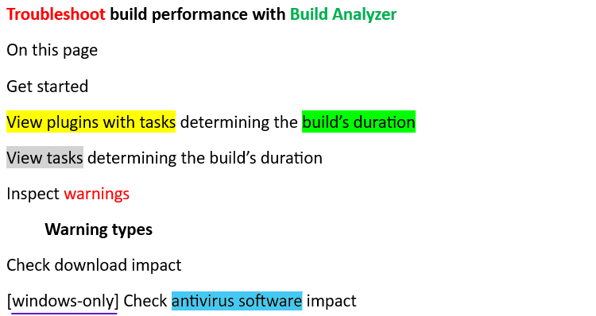

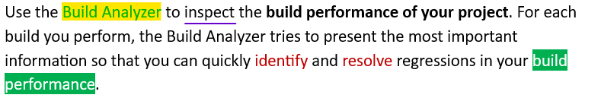



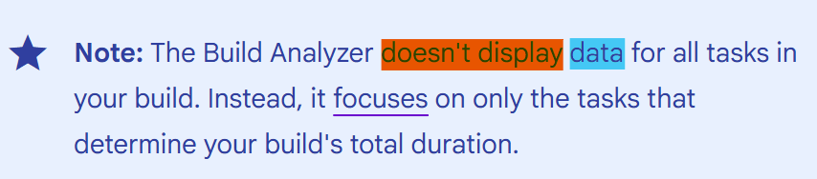

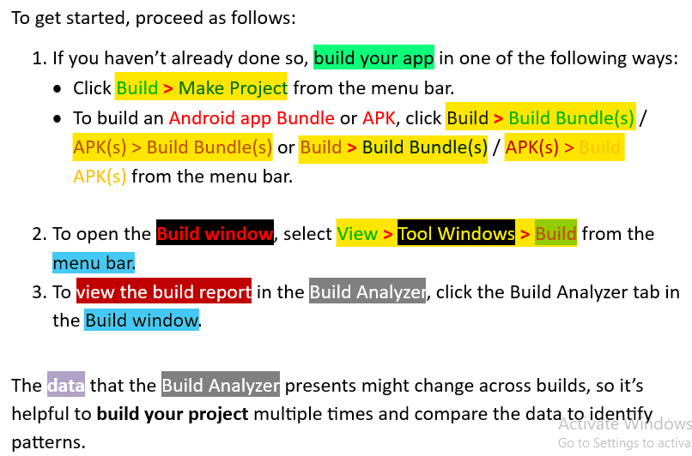

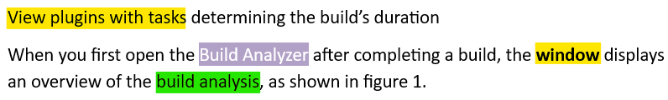

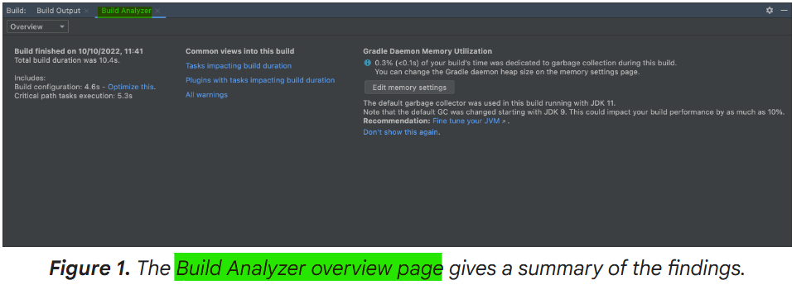

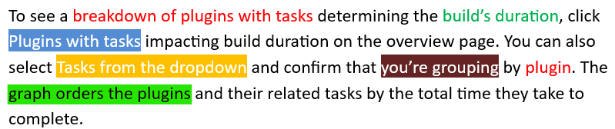

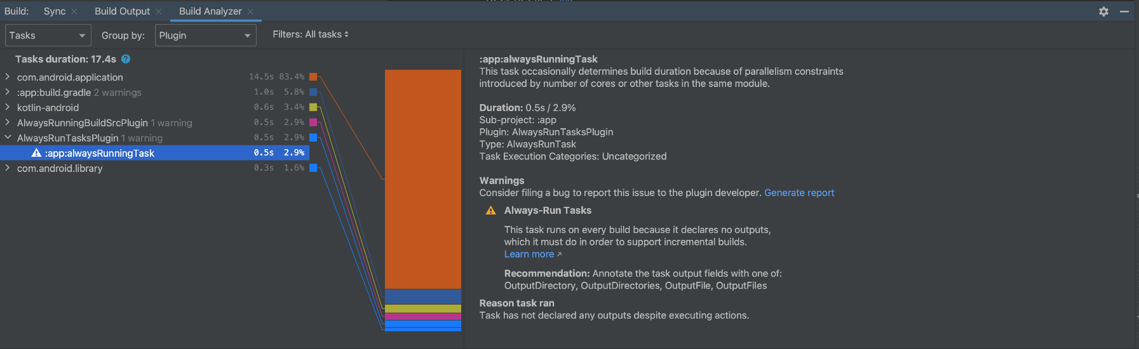

***Figure 2.****The Build Analyzer provides a breakdown of plugins that affect your build's duration.*

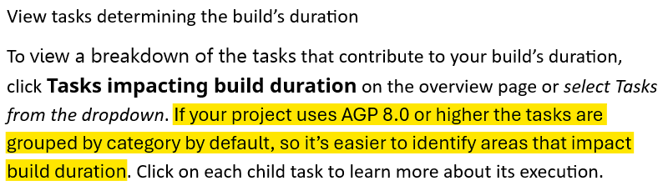

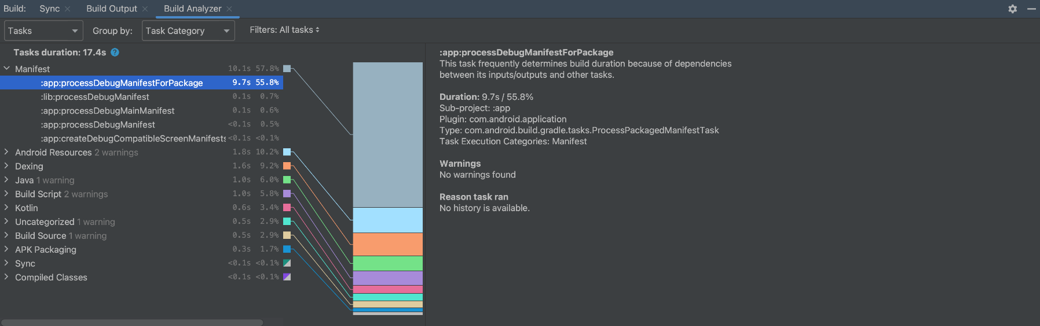

***Figure 3.****The Build Analyzer provides a breakdown of tasks most responsible for your build's duration.*

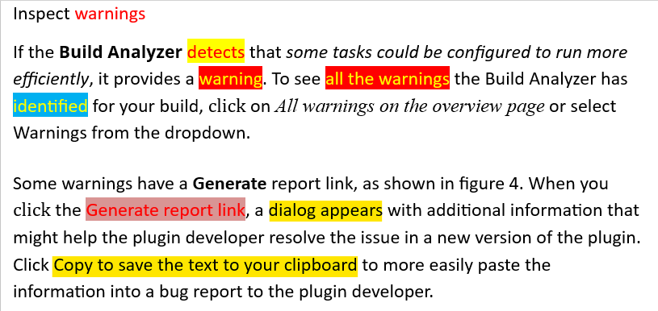

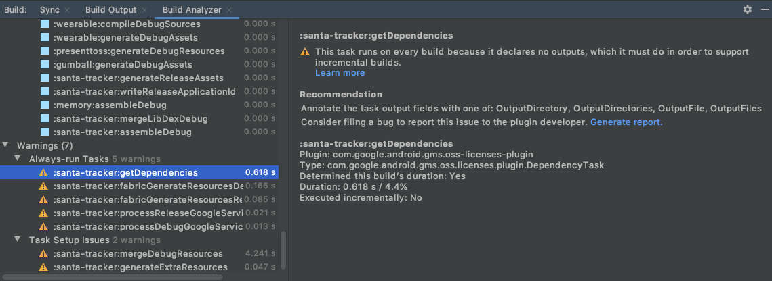

***Figure 4.****Detailed information about Build Analyzer warnings.*

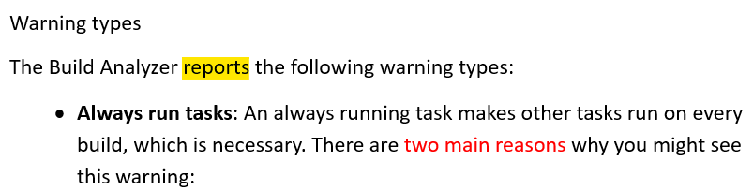

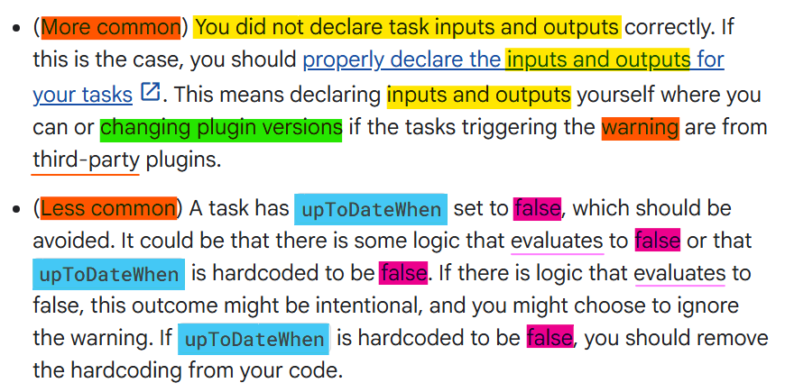

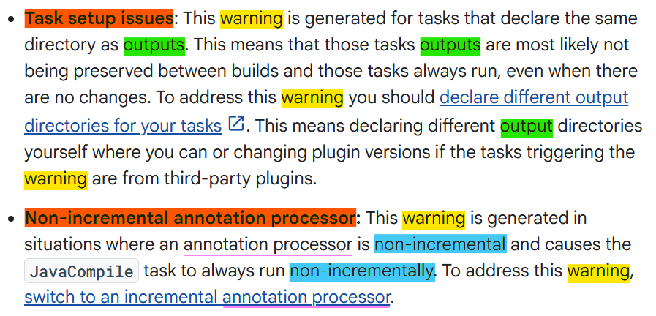

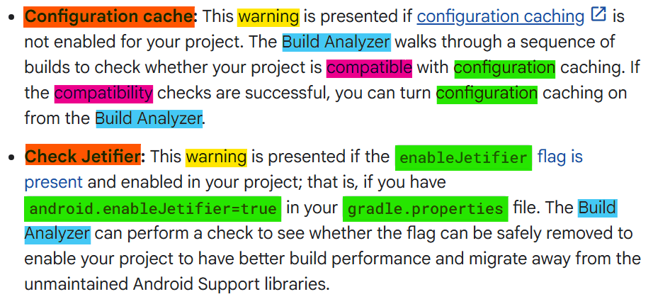

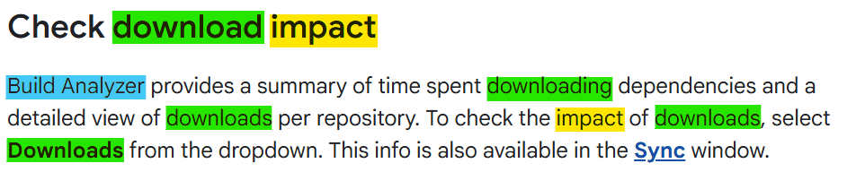

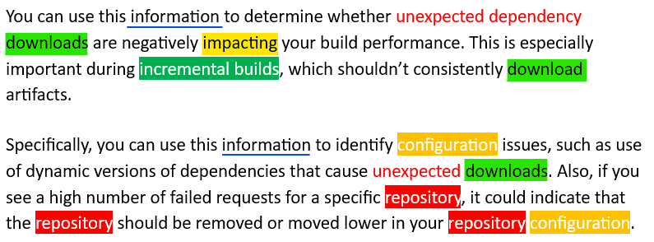

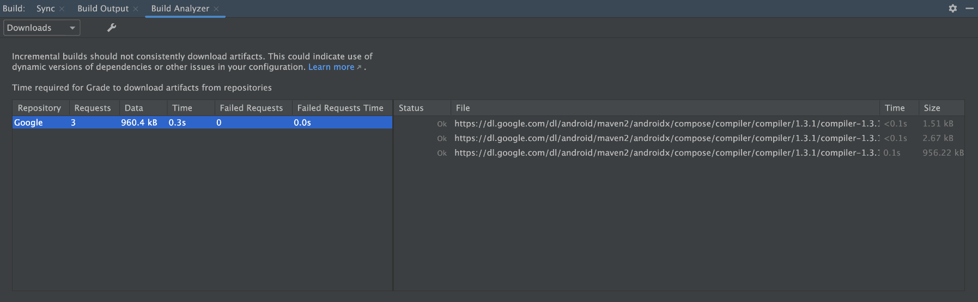

***Figure 5.****The Build Analyzer shows the impact of downloads on build duration.*

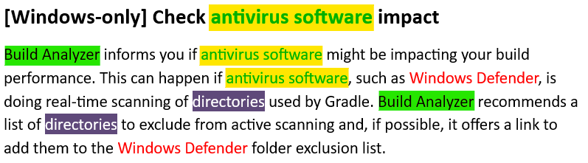

<https://developer.android.com/develop/sensors-and-location/location>

**LOCATION**

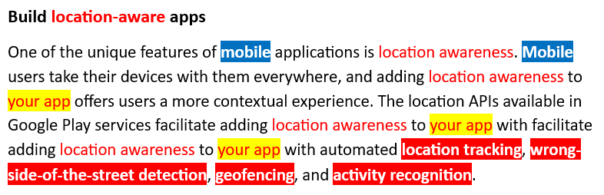

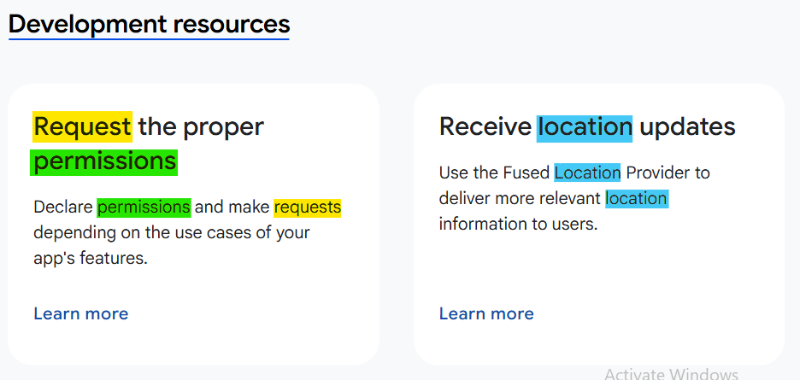

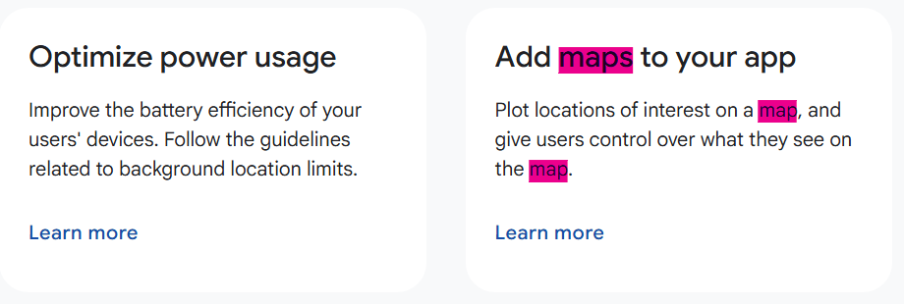

**Latest News**

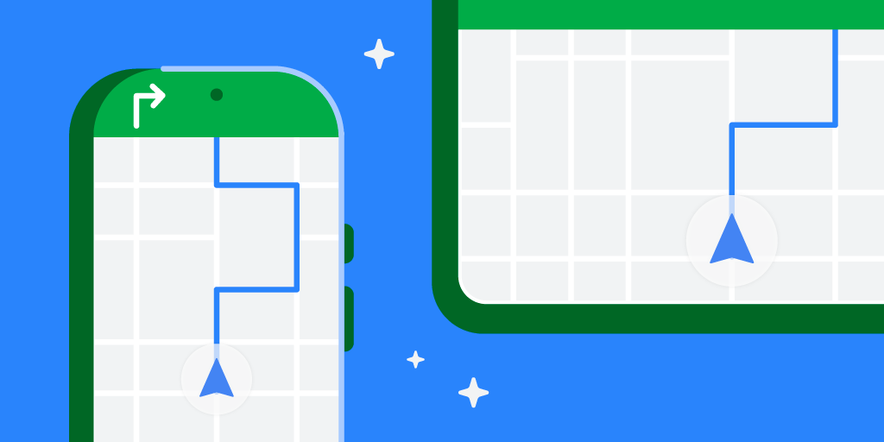

**Blog**

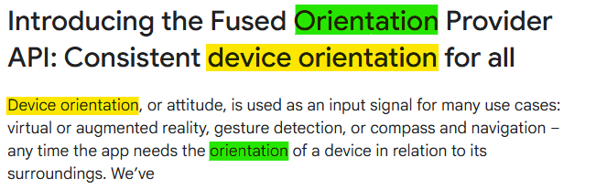

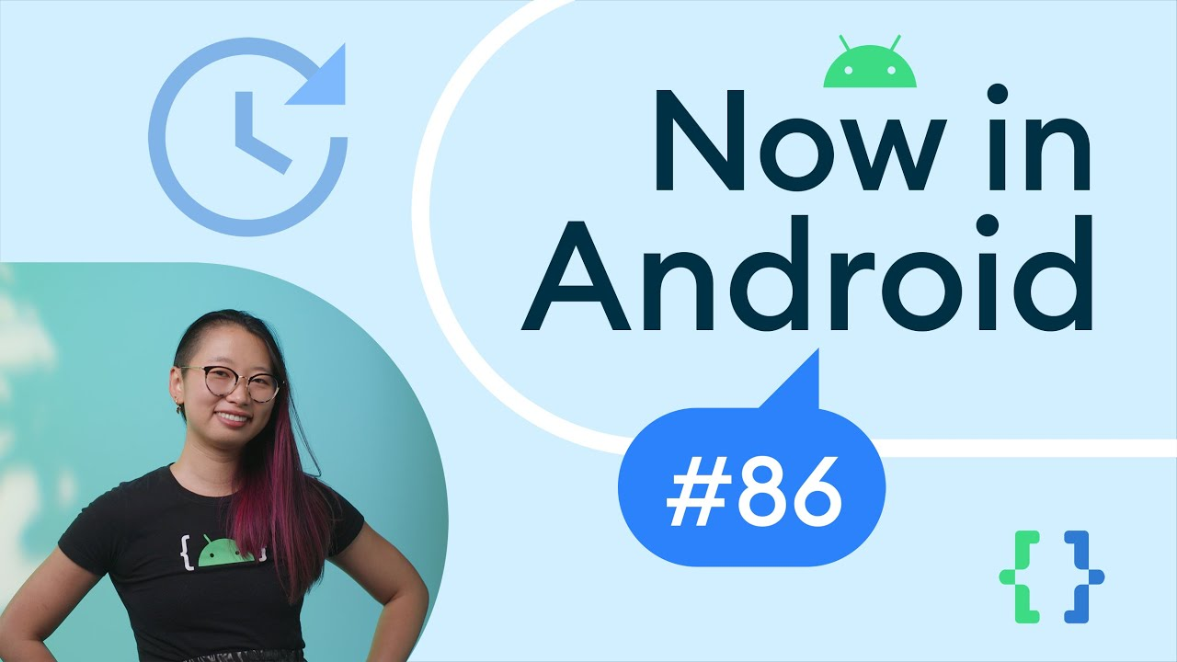

**Video**

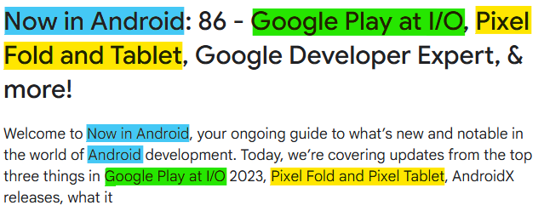



**Blog**

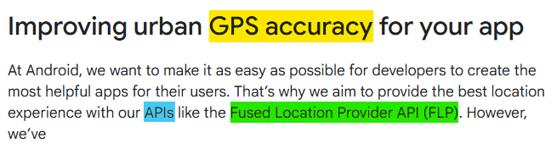

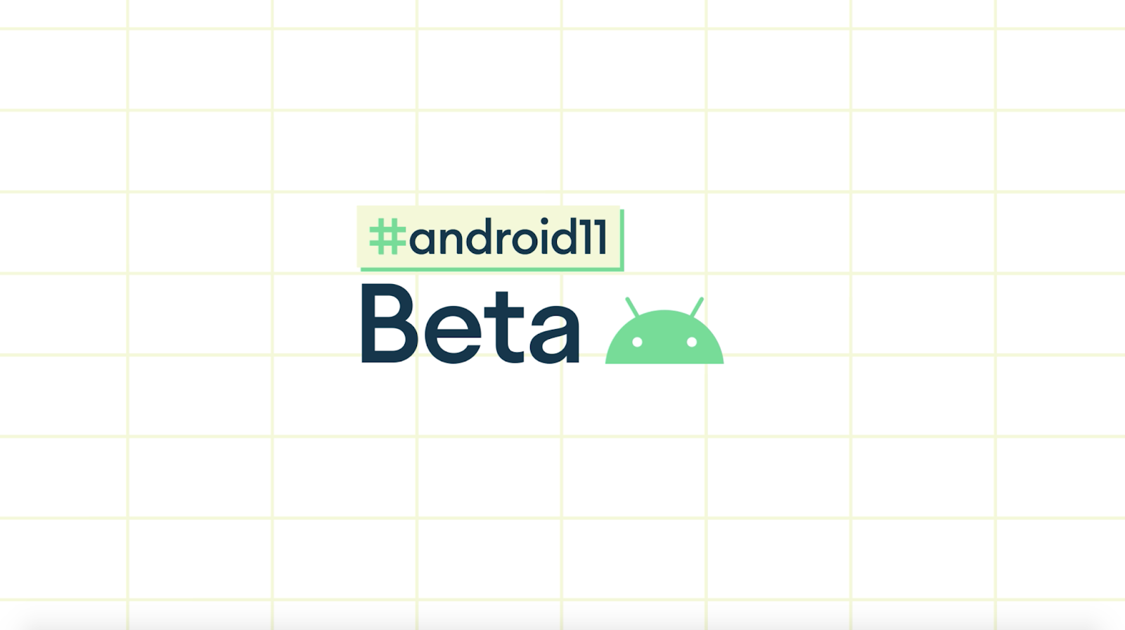

**Blog**

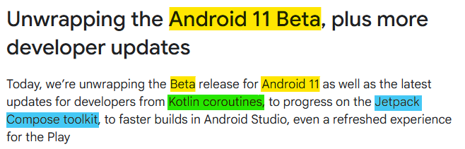

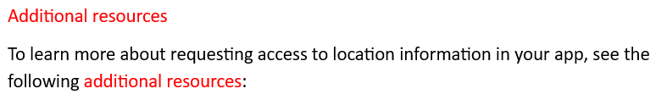

**Codelabs**



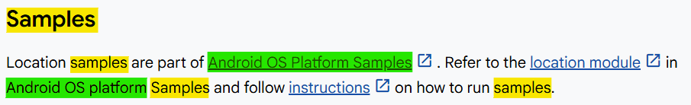

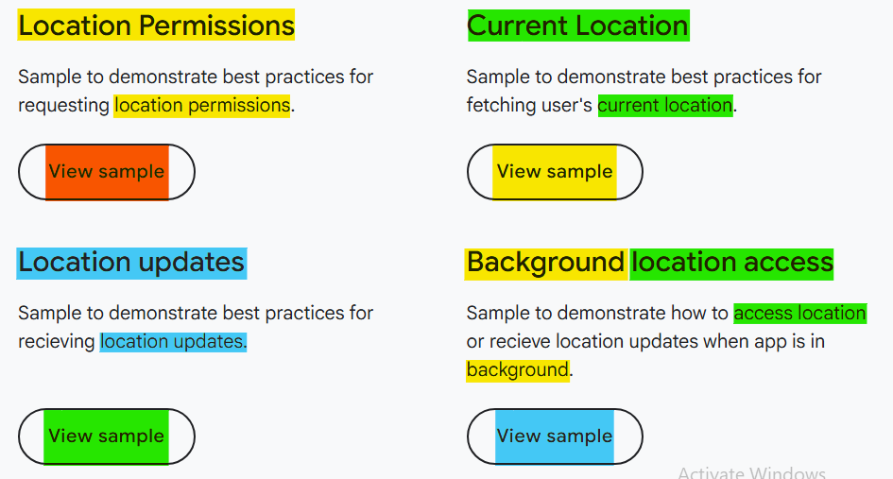

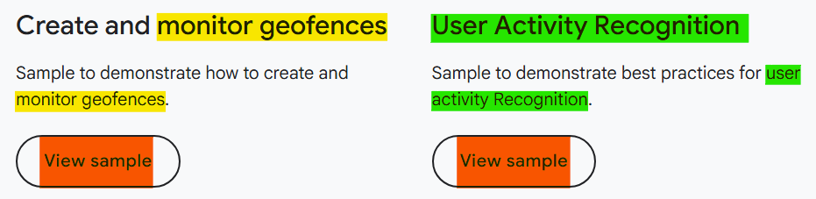

[**https://developer.android.com/develop/sensors-and-location/location/permissions**](https://developer.android.com/develop/sensors-and-location/location/permissions)

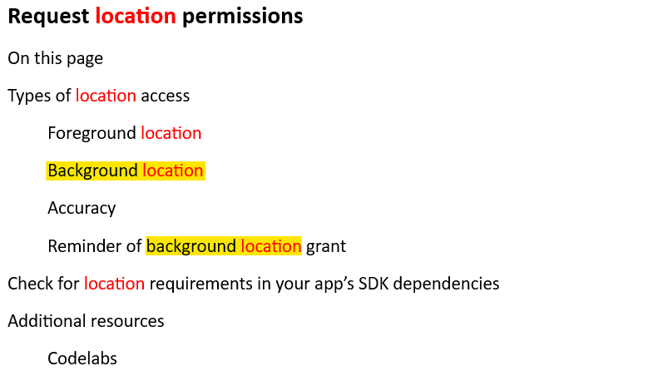

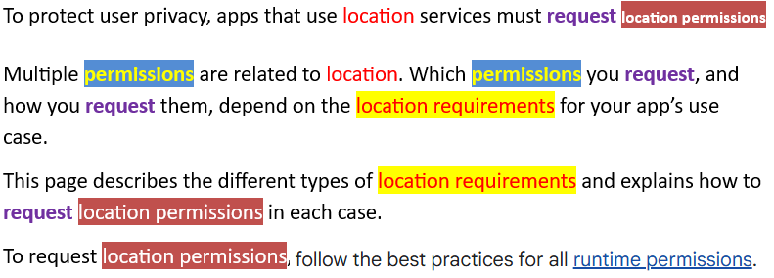

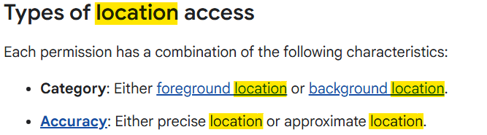

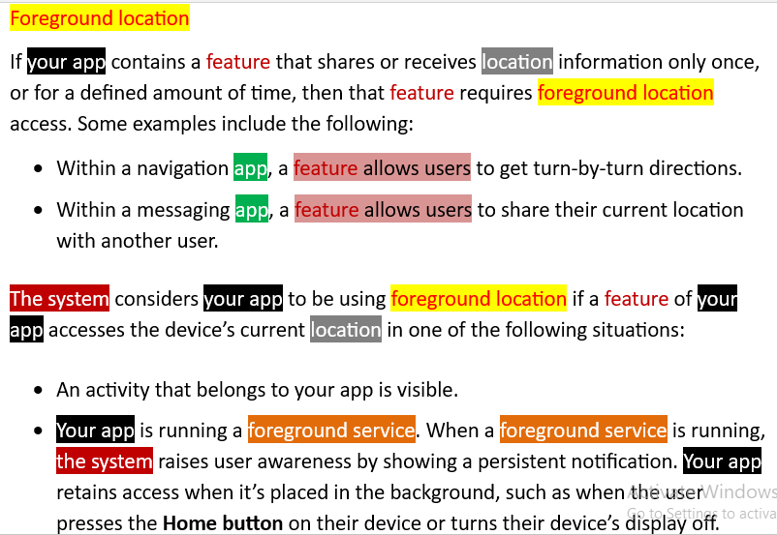

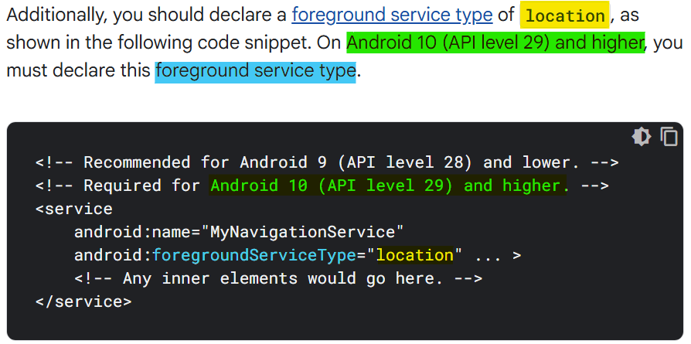

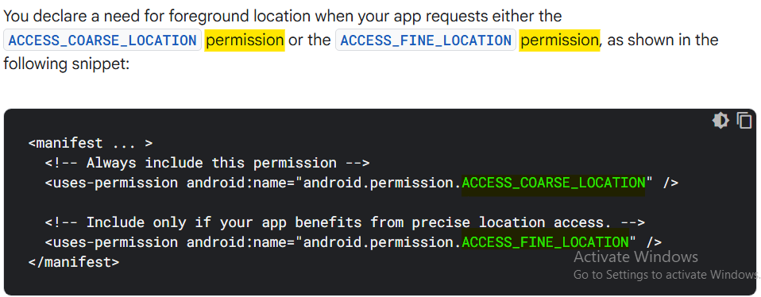

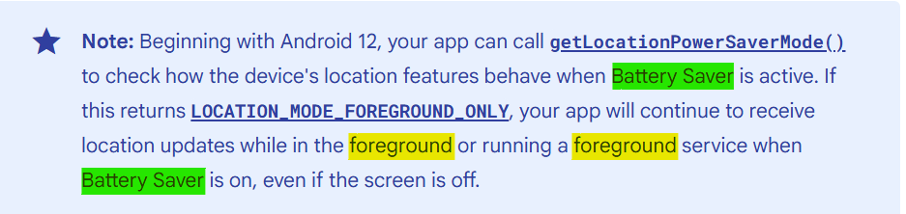

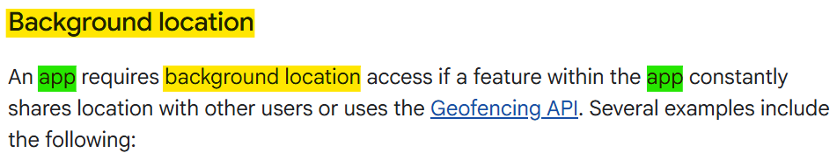

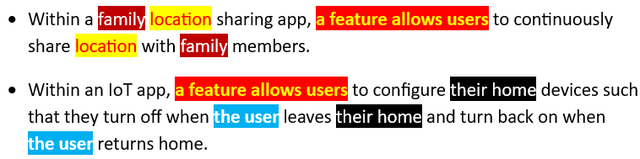

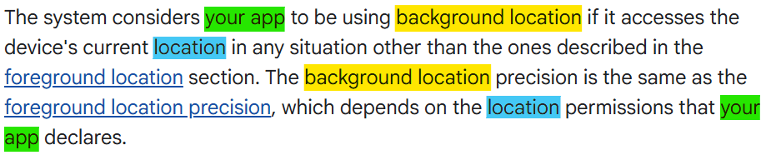

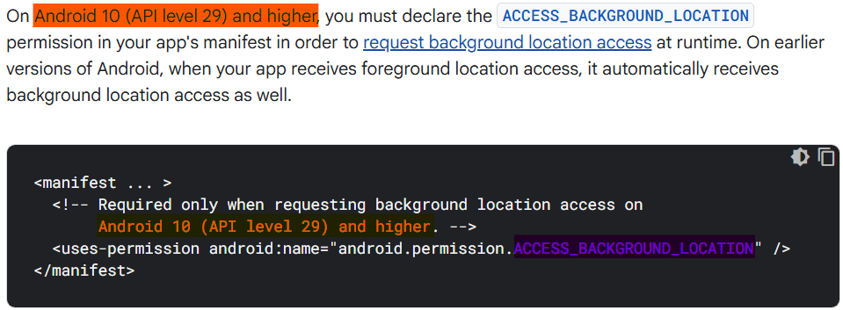

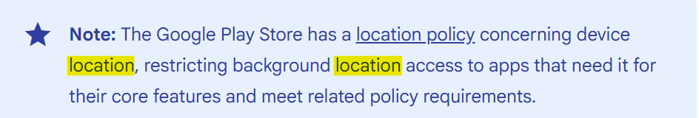

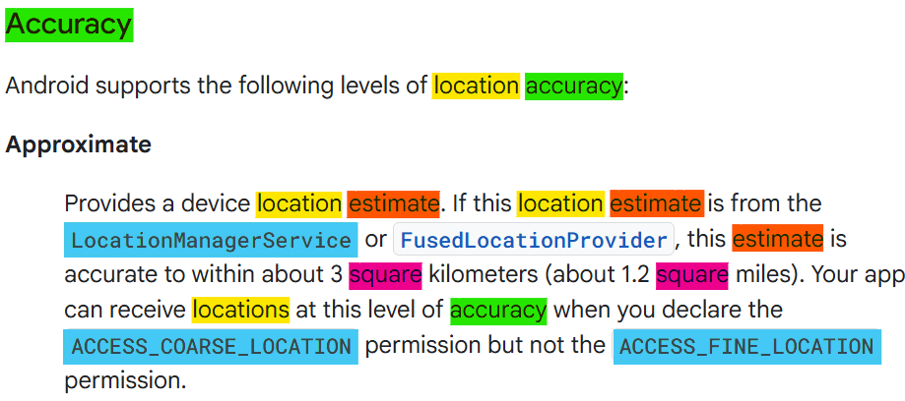

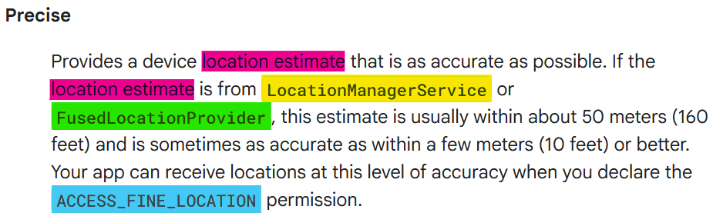

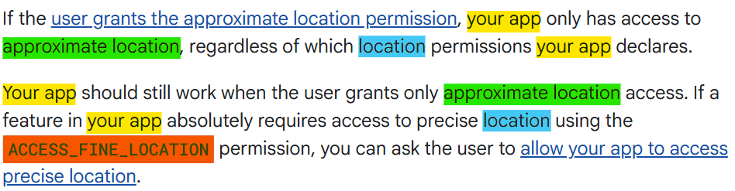

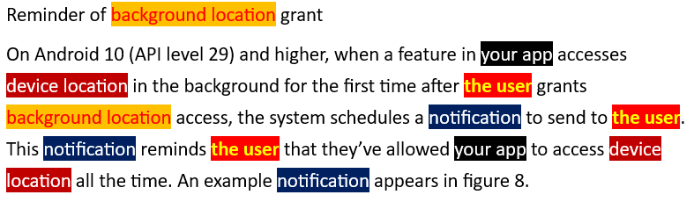

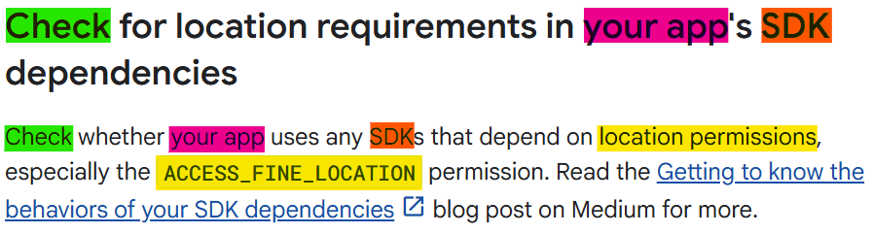

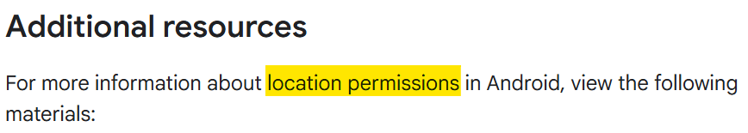

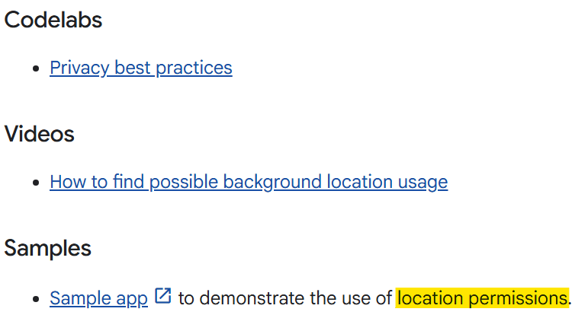

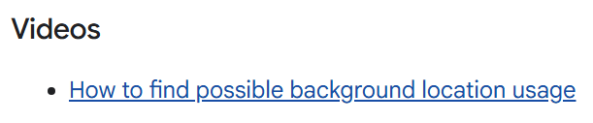

**Videos Start**

[**https://www.youtube.com/watch?v=xTVeFJZQ28c**](https://www.youtube.com/watch?v=xTVeFJZQ28c)

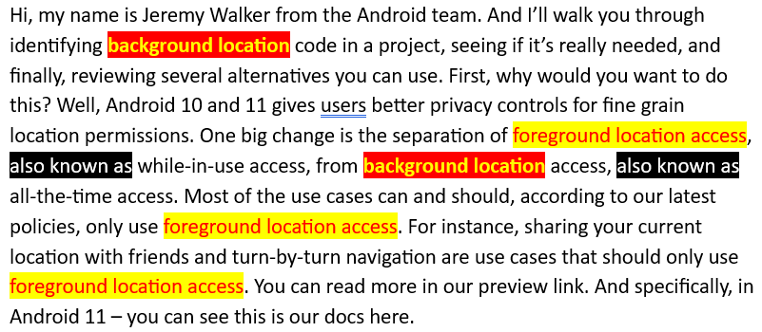

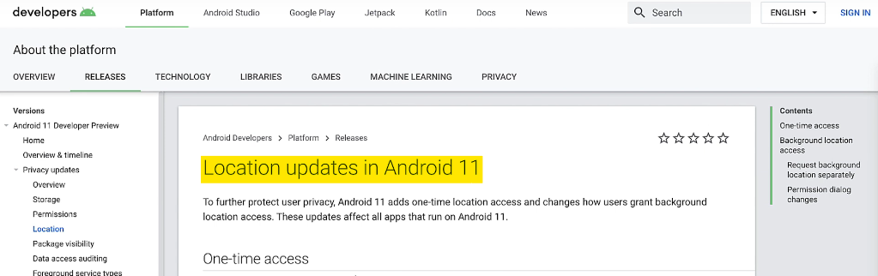

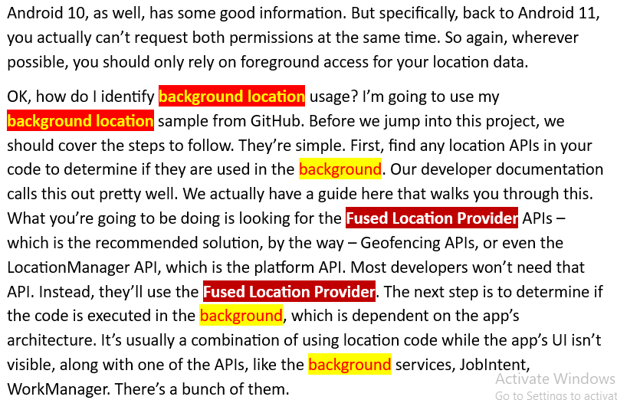

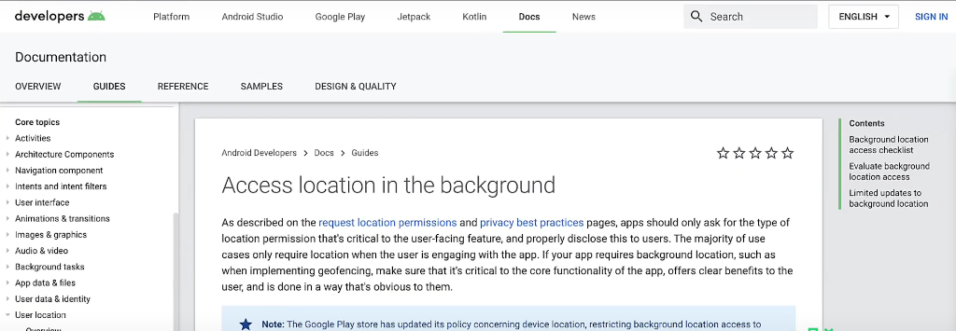

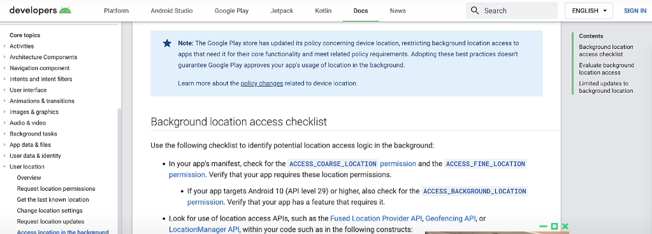

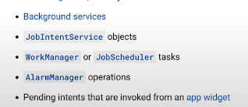

Or, even pending intents if you’re subscribing to updates. OK, now let’s walk through the code. So I’m going to pretend like this is an app. This app, again, is from the GitHub samples. It’s LocationUpdatesBackgroundKotlin, which is kind of a mouthful, but it shows best practices for getting location in the background.

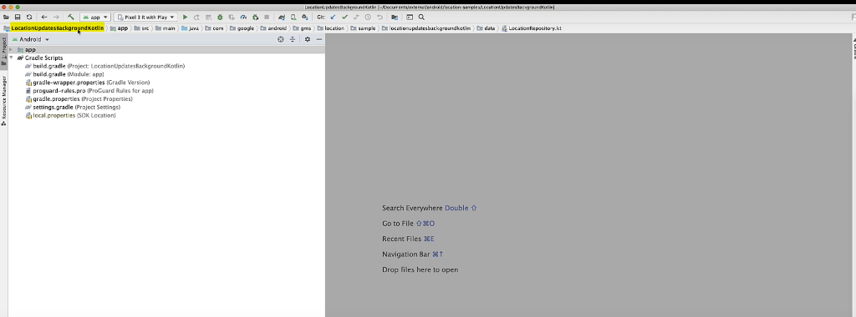

and I want to remove it really quickly. So the first thing, obviously, is, without even diving into the architecture, I can just do a double shift and search for –

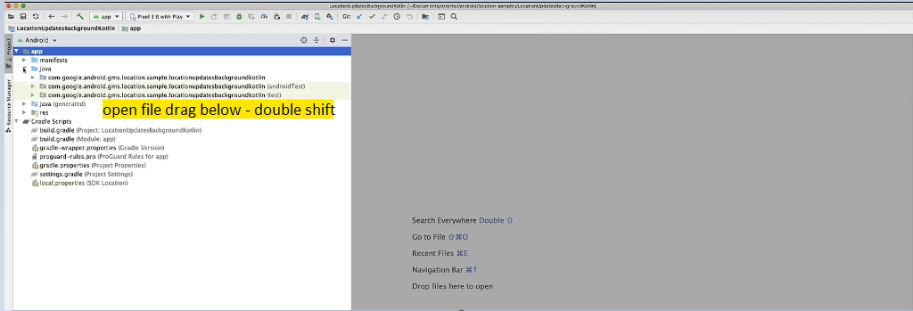

I’m using Fused Location Provider, so I’ll just start searching for that.

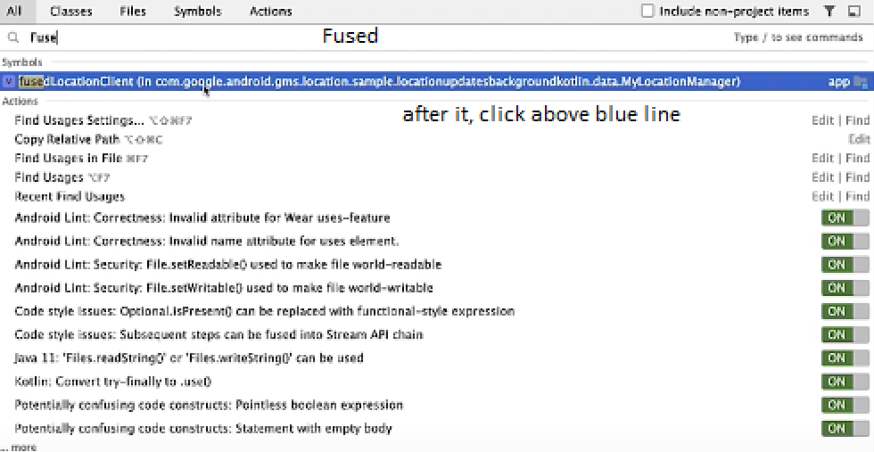

So I can see right away I have the fusedLocationClient, that’s the main code for doing this.

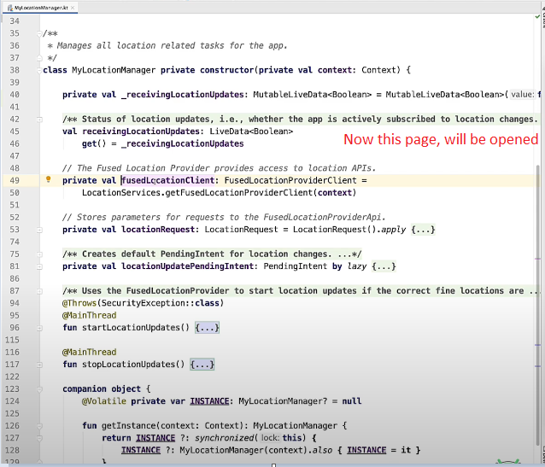

So in this case, I’m going to go look at the usage of this. I know I have this class is my location manager, so it’s being used somewhere. If I do Command B – that’s control B in other OS’ outside the Mac. But if I do a Control-B, it’s going to show usages.

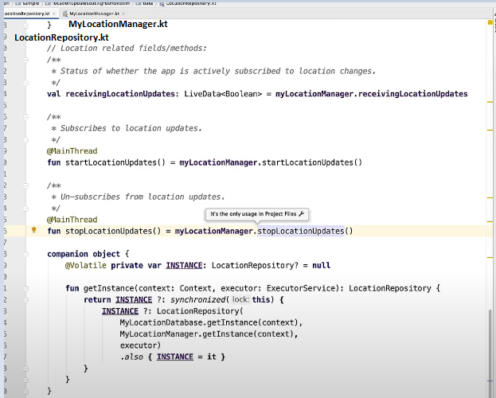

I can see I’m using location repository. And again, if I just do the location, if I just look for this method and how it’s used, I can see this is better. It’s in a view model.

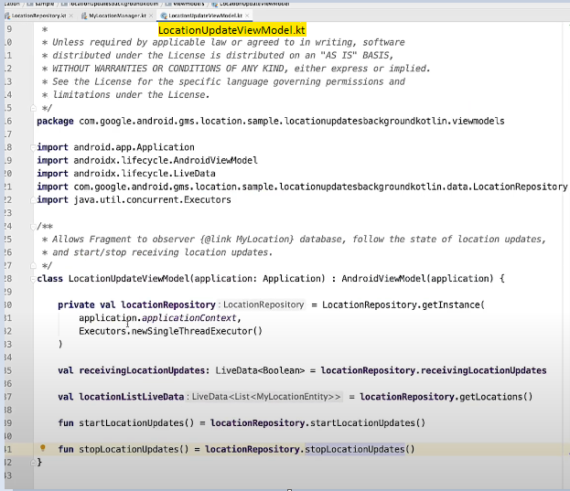

I know it’s being used with an activity or a fragment somewhere. So again, I can do the Command-B to find usage.

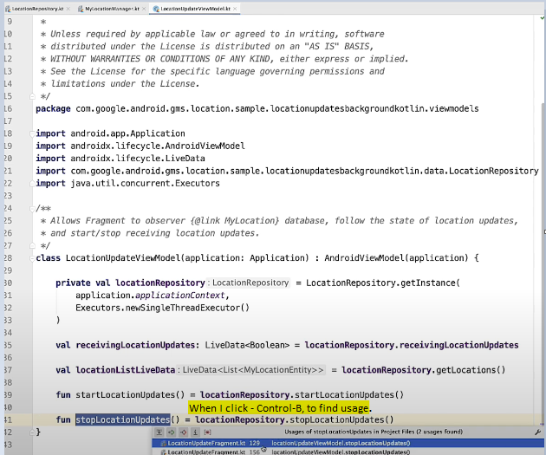

**It’s being used twice in this fragment. We will pick second one (above).**

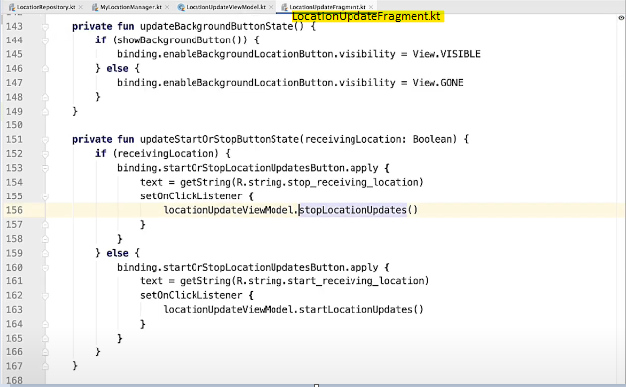

OK, there’s a UI code I was looking for. And if I just glance at this, I can see, OK, this is some sort of button state. It’s being triggered. And it’s either subscribing to – it’s either starting location updates or it’s stopping them. So the user is stopping them with a button.

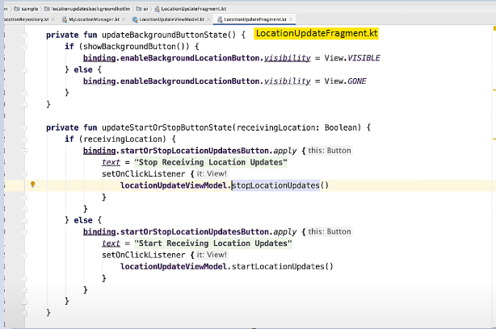

But if I look for this again here, I can see it’s used somewhere else. Oh, and on pause.

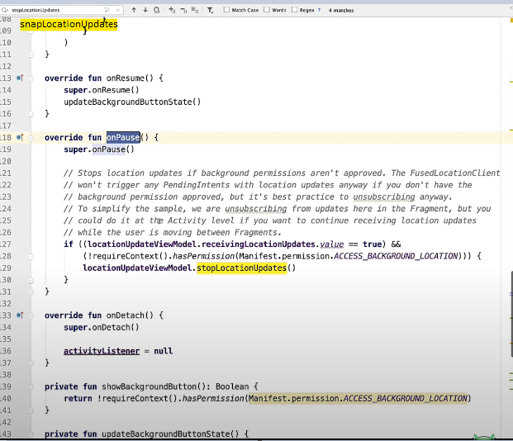

So that’s pretty much what gives me the clue, like, is this in the foreground or not? You can see I actually called stop location updates on pause, so that would mean I’m only using it in the foreground, which is perfect. But if we look at this IF statement, you can see I’m saying, hey, if I have ACCCESS_BACKGROUND_LOCATION permissions, I don’t want to stop this.

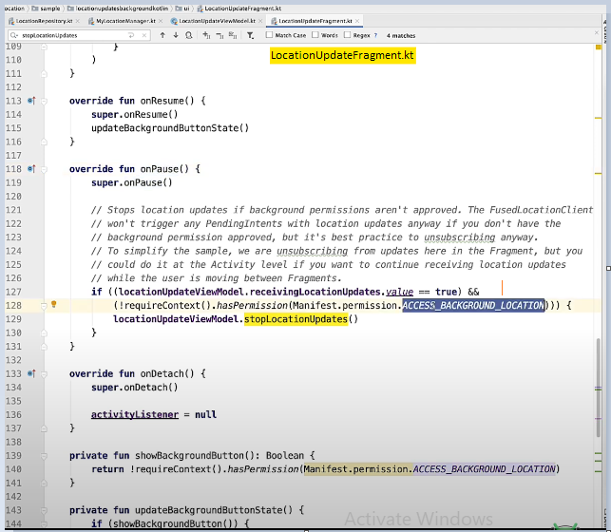

So in that case, then I’d say, OK, this is triggering in the background separate from all the permission stuff. So this is something I may want to change. OK, that’s pretty obvious, like, you’re just searching and finding your code and figuring it out.

The next part is more about how your app uses location, specifically, is background location needed? You should evaluate whether background location access is critical to the core functionality of your app. As mentioned earlier, most use cases can be realized with only foreground location. We actually have a page that covers that.

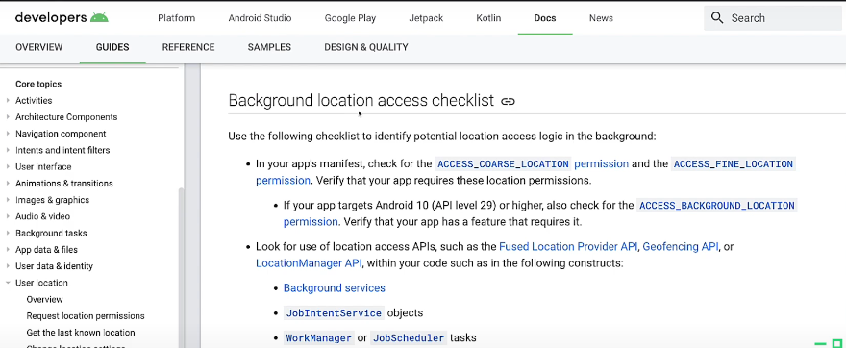

If you remember, this Access location in the background, which I covered earlier.

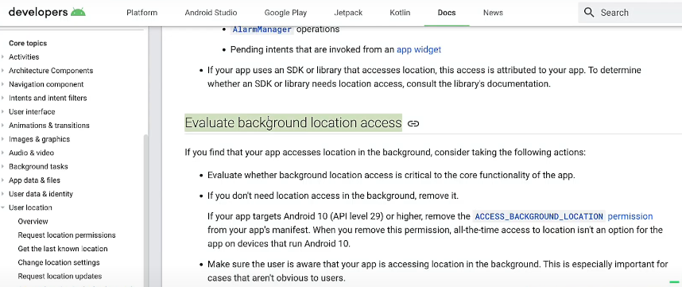

There’s a whole other part about evaluating whether you really need it. But if you don’t need location access in the background, either migrate to foreground location access or remove it altogether. It will simplify your app and code in both cases.

Just remember for Android 10 and above, and 11, you have to remove this permission from the manifest – ACCESS_BACKGROUND_LOCATION so that would be right here.

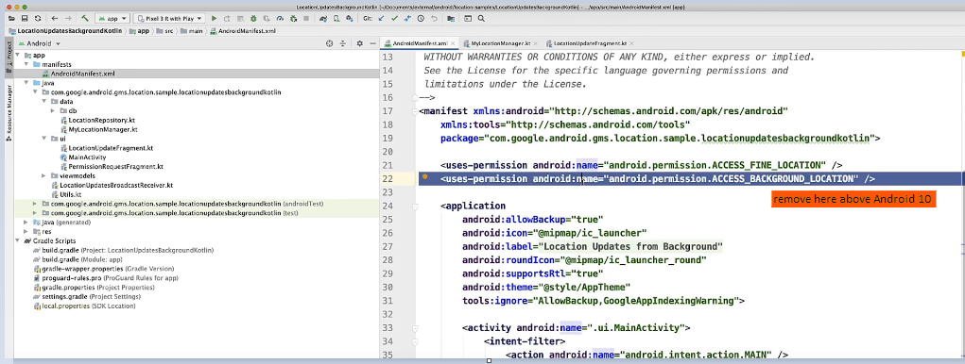

You want to make sure you remove that from Android 10, 11, above. That said, if background location is still critical, make sure you follow best practice and review our policies on location.

OK, let’s say you do want to migrate to foreground location access. That is, you’ve determined you don’t need access location in the background. The first option is only retrieving location while your activity is viewable. And it’s probably the most common approach. In this case, it would just mean you don’t request any location data, like get last location, when your app isn’t available.

For this sample, what it would mean is in the fragment on the onPause, I would stop location udpates.

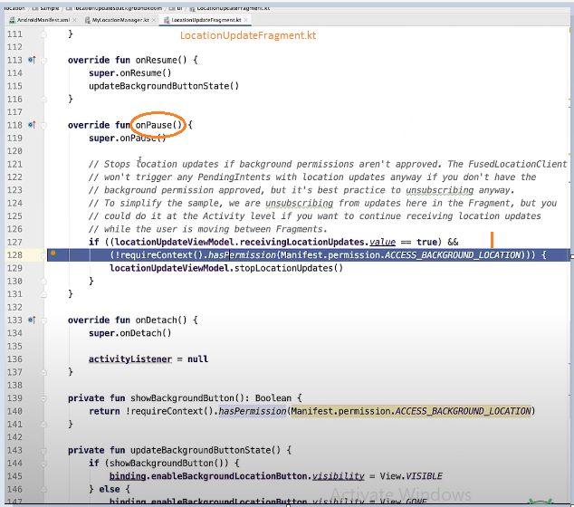

In other words, I’d remove this line so that I knew every time that the UI went out of view that it would stop listening to location updates. And if we click through to what that actually does, you can see it’s just using the Fused Location Client and just removing location updates. OK, that’s pretty straightforward. It can cover a lot of use cases. But there’s another option for foreground location.

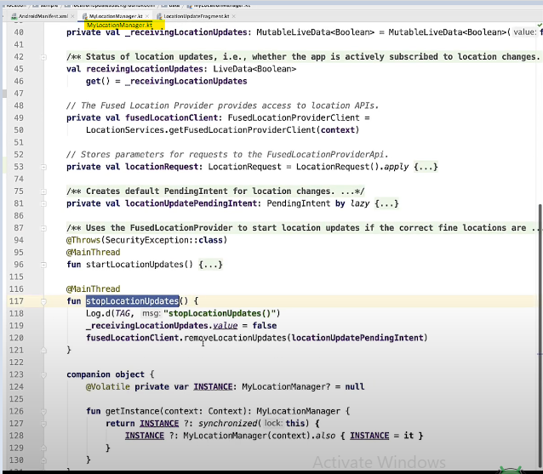

Your app can also retrieve location via a foreground service without the background location permission. This is a little more difficult. Let’s look at the Codelab to see how we design this. So if you search for Google Codelabs, this is the first thing that comes up. And if you put it in location,

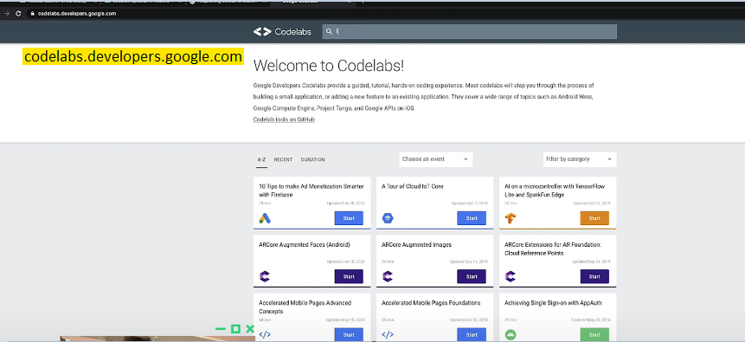

you want to choose the Receive location updates in Android with Kotlin.

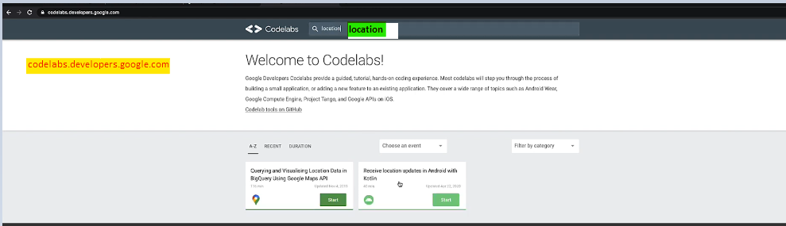

[**https://codelabs.developers.google.com/codelabs/while-in-use-location#0**](https://codelabs.developers.google.com/codelabs/while-in-use-location#0)

Your app can also retrieve location via a foreground service without the background location permission. This is a little more difficult. Let’s look at the Codelab to see how we design this. So if you search for Google Codelabs, this is the first thing that comes up. And if you put it in location, you want to choose the Receive location updates in Android with Kotlin.

This codelab actually walks you through understanding and writing the location code. It also touches on permissions, and it helps you support Android 10 and 11. I won’t walk through that. I’m going to focus on the design, because this codelab actually only uses foreground location, which is pretty nice. So I have the app open here, but I want to show you the actual app first before we dive into understanding the design. So if I actually start navigating here, yeah, you’ll see that we have the app open.

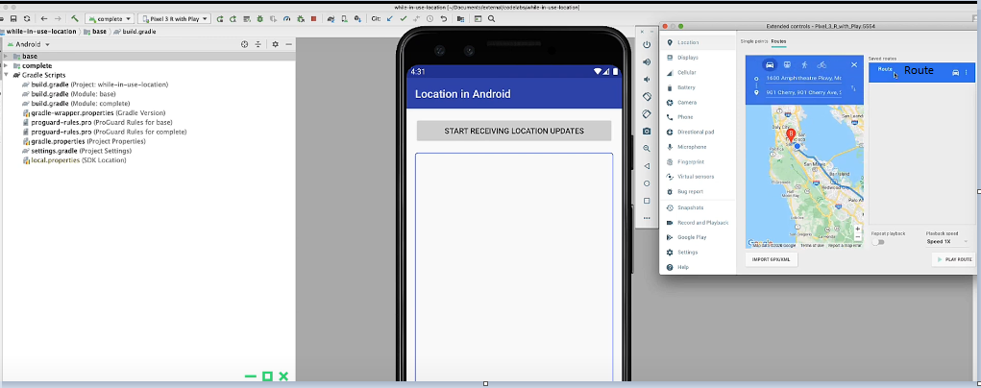

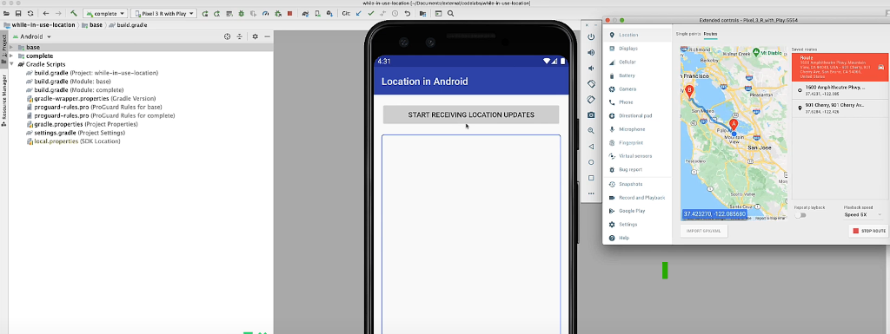

If I hit Start Receiving Location Updates, I’ll get While using the app

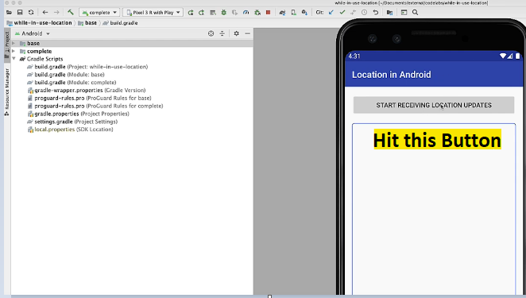

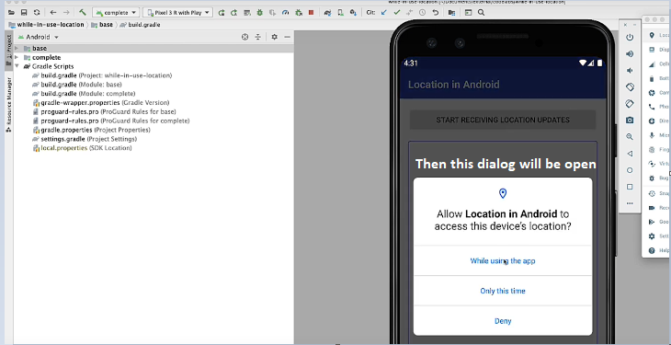

**Pretty straightforward.**

I click on that and – oh, sorry, Yeah, so I’m getting location updates now. And if I navigate away from that, you’ll see I get a notification that comes up. And that gives us continual updates as they come in. And if I scroll down, you can see the location.

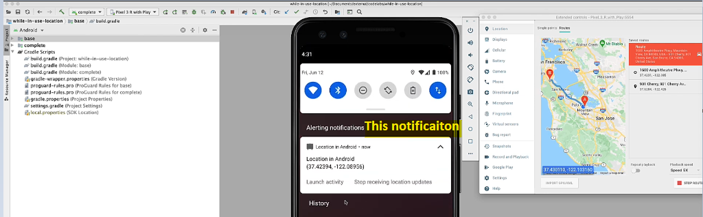

I can watch the activity or I can hit Stop Receiving Updates. So you’re probably like, “Yeah, that’s just like a navigation app.” And that’s pretty much what it is. But again, it’s only using Background location, which is pretty nice. So do we have a service retrieving location in the app. And I’m going to talk through that in detail. But when the app is paused, the trick is transitioning that service to a foreground service and tying it to a notification. That way your app is still in use and you can continue to get location updates without background location access. Before I open this up, it’s important to point out you shouldn’t just replace all code retrieving location in the background with this approach. First, determine if you should really be retrieving location data in that instance. In most cases, you should be requesting location data in the foreground only if the user initiated an action requiring location, like navigating to another place. Again, review our policy documents for more details. How is this done? Well, in the complete module – this is the complete part of the app. This is in Codelab, so you’re going to have a base module where you build everything out. But in the complete module where everything’s done, you have three main classes. You have the main activity, which is going to be your UI stuff.

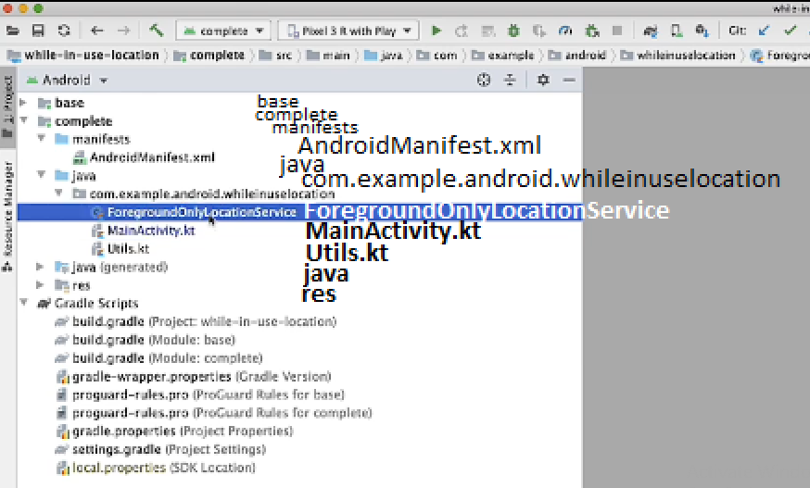

You have a service. In this case, it’s doing all the location stuff, and it’s going to handle the heavy lifting for transitioning to a foreground service and back.

And then, a utils class, which I won’t cover,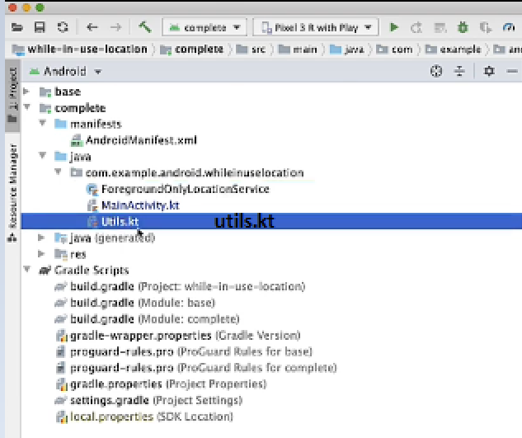

but it has some extension functions and provides some other stuff.

But anyway, let’s look at the main activity. I won’t cover all the code again, but I’m going to cover the main parts for the design. The main thing here is that I have an instance of the service here.

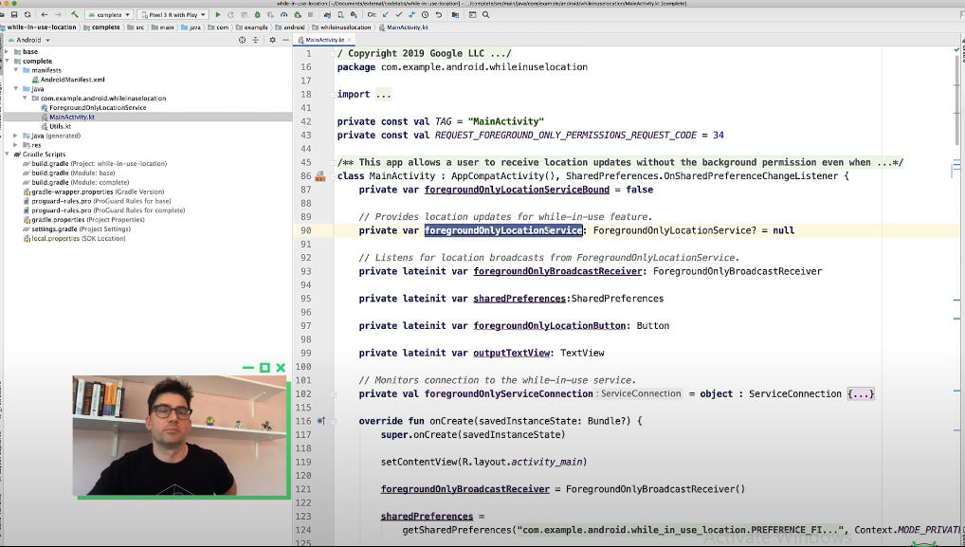

I do have a broadcast receiver you can see here.

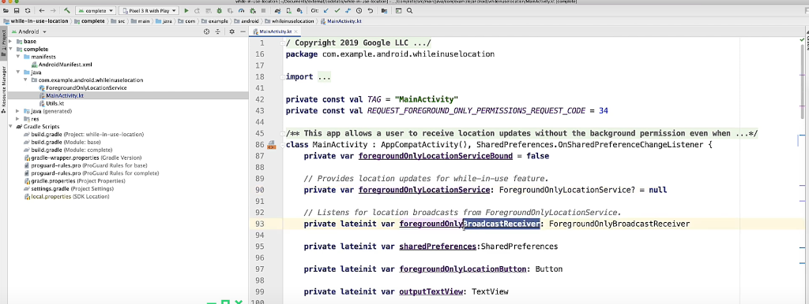

The reason I have that is, in the service, I was simplifying things, so whenever I get a location update, I just use a broadcast to send out the information. If you wanted to make this a little more – add a database and all that good stuff, you’d use LiveData and Room and all that stuff. But again, I was trying to simplify it, so that’s why that broadcast receiver. I have a service connection.

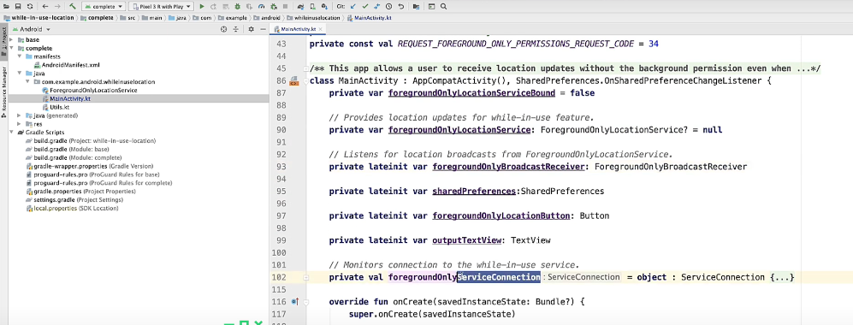

And this is – so I can bind to the class – so you can see here. And on start, I’m binding to the class.

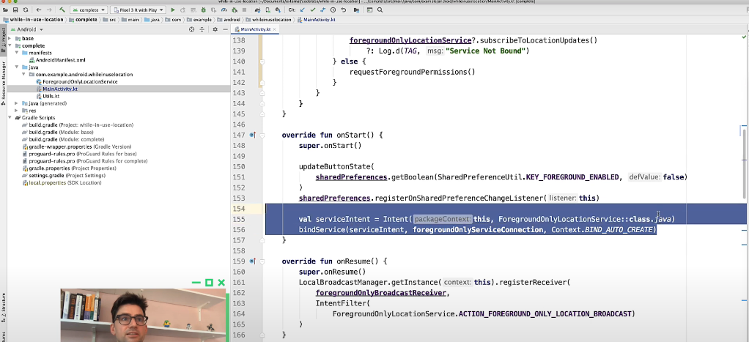

And this is – so I can bind to the class – so you can see here. And on start, I’m binding to the class. And then on stop, I’m unbinding.

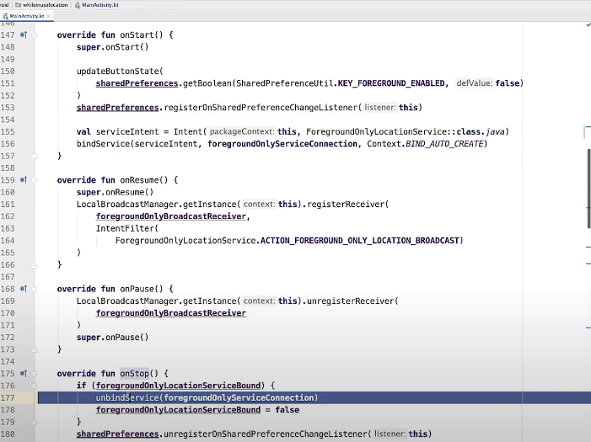

And then on stop, I’m unbinding.

And binding to the service just let – it lets me call methods in the service directly. So that’s what I’m doing. I only have one click listener for one button,

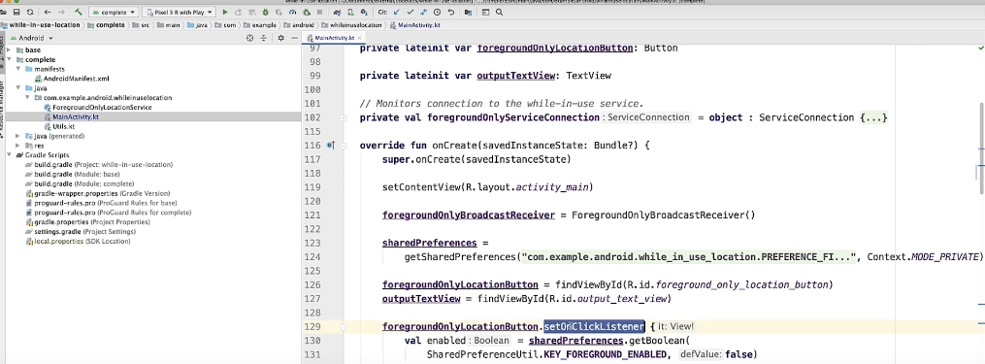

but you can see right here, it unsubscribes to location updates or subscribes to location updates. Pretty straightforward. That’s really it. So the summary of the classes, it’s binding to a service which handles all the location code. It knows nothing about it. And this lets us cleanly separate the location code from the activity in the UI.

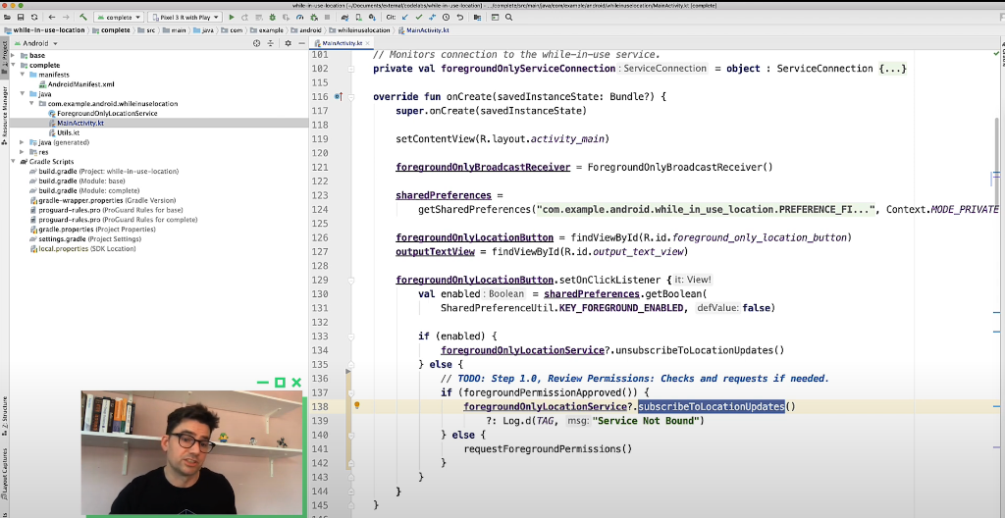

The other nice feature is when we want to support location updates in a foreground service, we can easily do that. How? Well, let’s look at the foreground only location service to figure that out. So there’s quite a bit code here. You have the location code, which I walked through in the Codelab. You can see in onCreate is actually where I initialize all that. There’s a start command and other stuff. You can see I have the subscribe to location updates. That’s where all the location code is to get it started. And then you have unsubscribe to location updates. The most important thing is, A, I give them a method to call to subscribe to location updates. But the cool thing is, because all this location code is separated, I know that when they unbind for me, that the activity is going away.

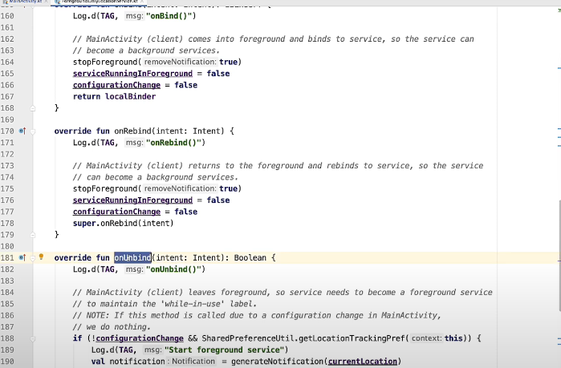

It’s no longer going to be visible. So if they’re actively subscribed to location changes and I get this unbind request, then I know that I need to transition the service to a foreground service. So in that case, I create a notification.

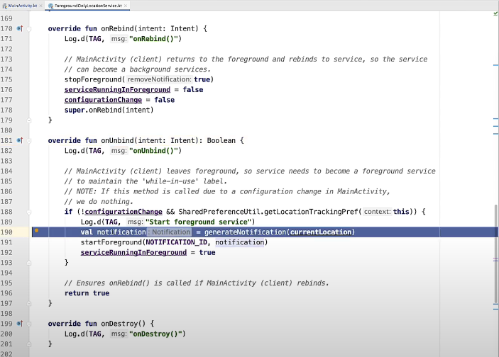

And then I basically transition it to a foreground service. And then if the activity comes back and re-binds to me, that’s great. Then I basically stop it as a foreground service and remove the notification. Again, I do that with onBind as well. But that’s kind of the magic. So there’s a little more to it. Well, no, there really isn’t any more to it. That’s the basic thing. If you want to dig into the location code, then there is more to it. But what you’re basically doing is, you’re using a service to retrieve the location for the activity via binding. And we promote that service to a foreground service for the notification when the activity is no longer visible. We still get location changes, even when the app isn’t visible. It is with the notification, but you don’t have an activity visible. And you don’t need background permissions. One other final note. So in the manifest, you do have to say all your foreground service – if you have a foreground service, you have to say what type it is.

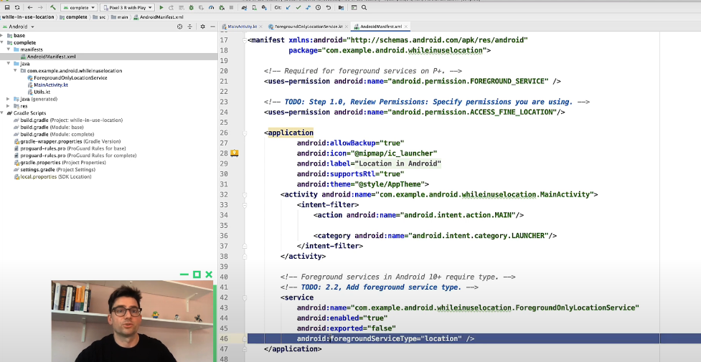

In this case, location. So this is a requirement for 10 and above. So it’s a common mistake that you want to avoid. So make sure you review your manifest for foreground services using location, and add that. Anyway, I hope you found this screencast useful.

If you want to learn more about managing location in Android 10 and 11, please visit the training page.

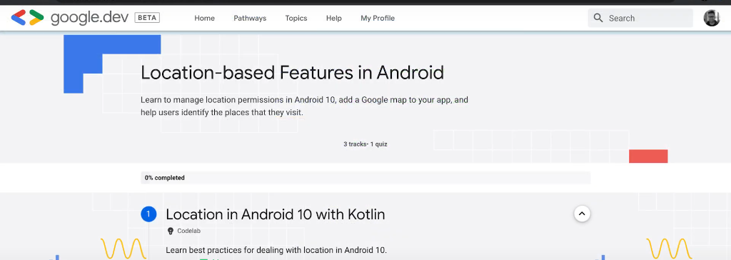

**Thank You.**



[**https://github.com/android/platform-samples/tree/main/samples/location/src/main/java/com/example/platform/location/permission**](https://github.com/android/platform-samples/tree/main/samples/location/src/main/java/com/example/platform/location/permission)

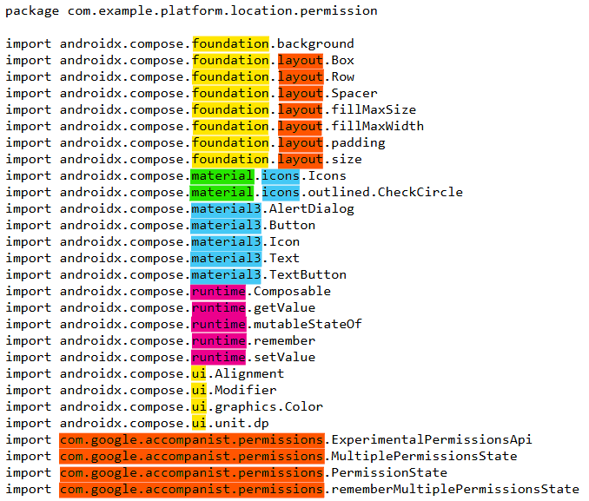

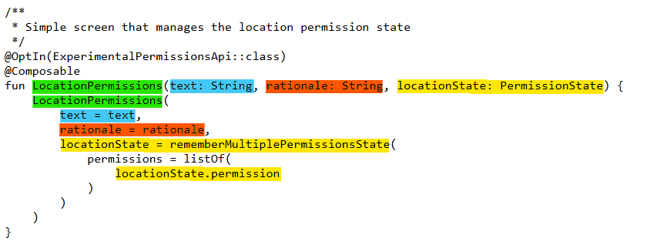

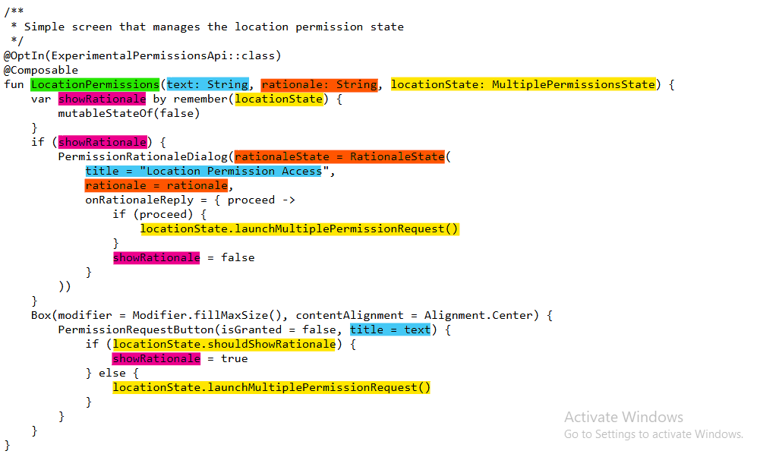

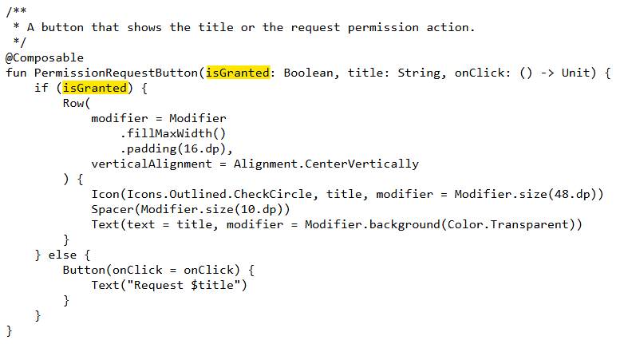

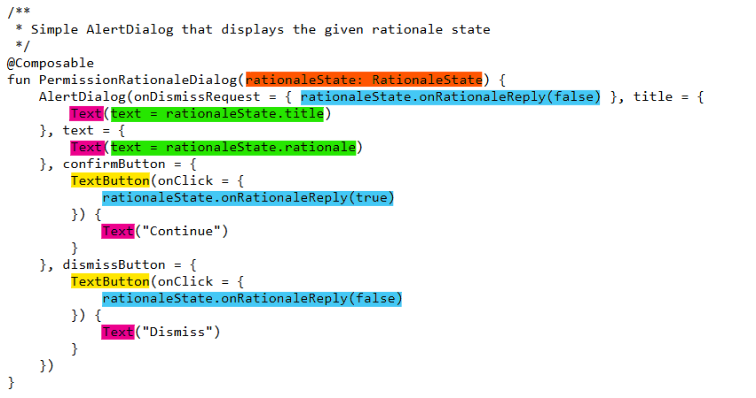

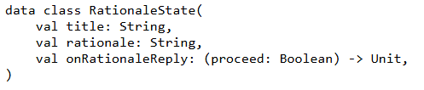

**samples/location/src/main/java/com/example/platform/location/permission/LocationPermissionsScreen.kt**

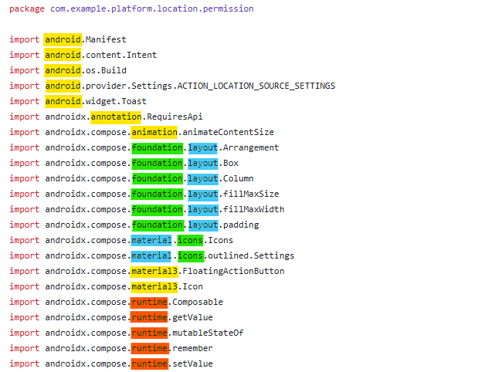

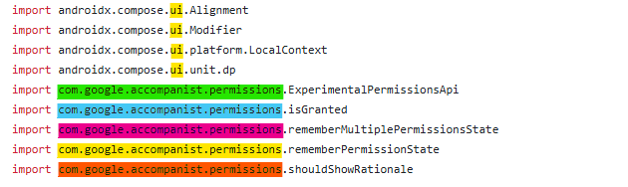

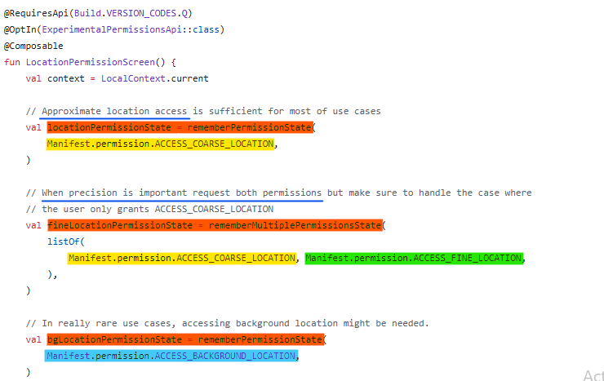

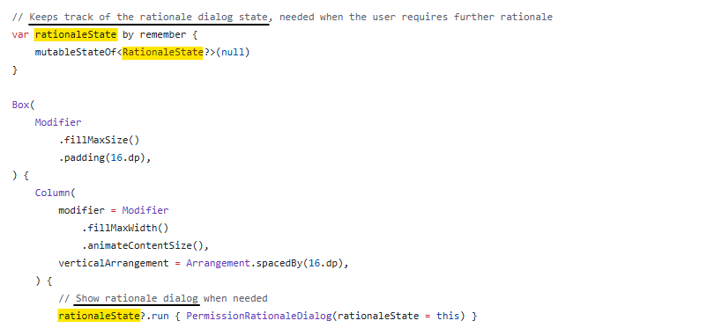

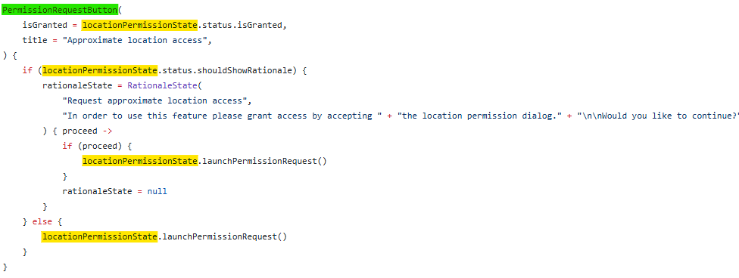

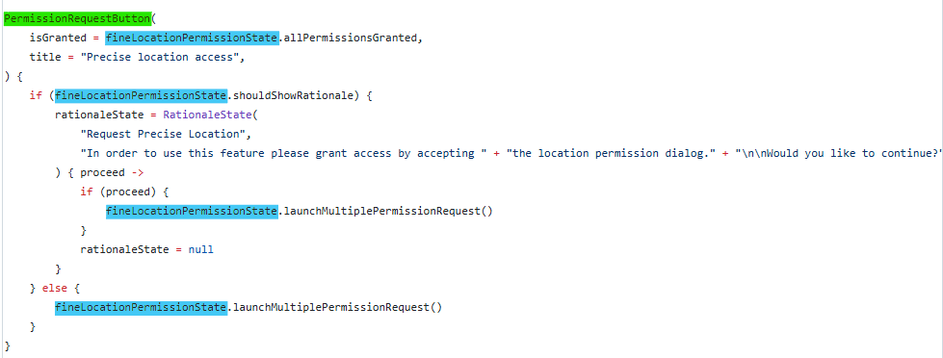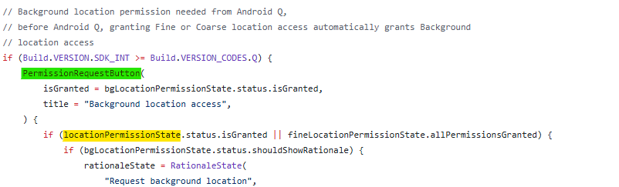



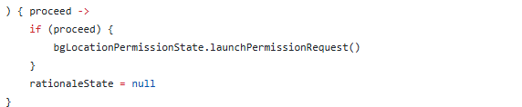

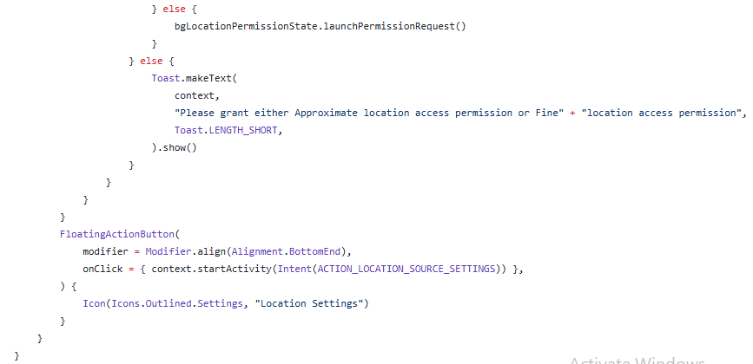

[**https://developer.android.com/identity/sms-retriever**](https://developer.android.com/identity/sms-retriever)

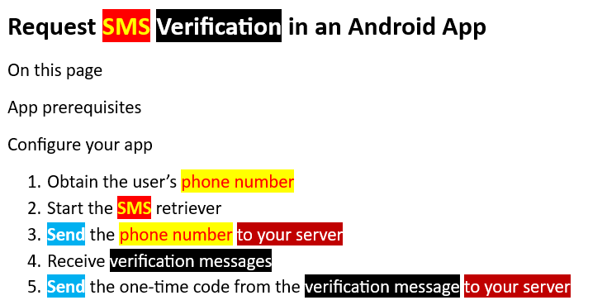

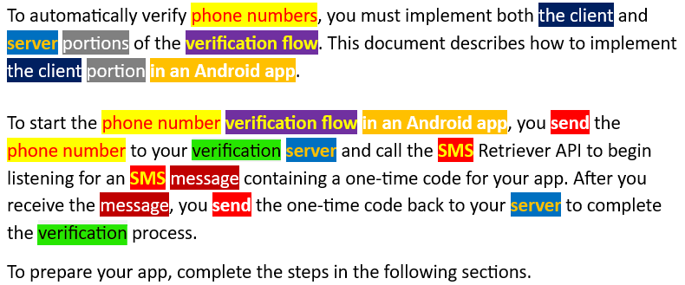

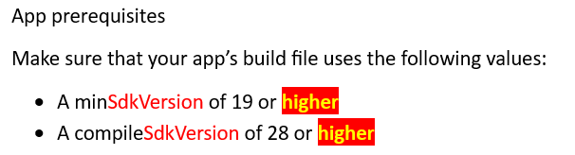

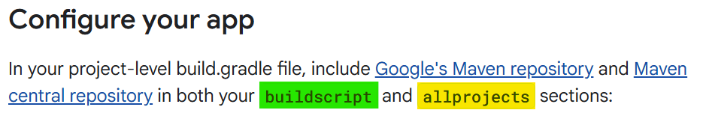

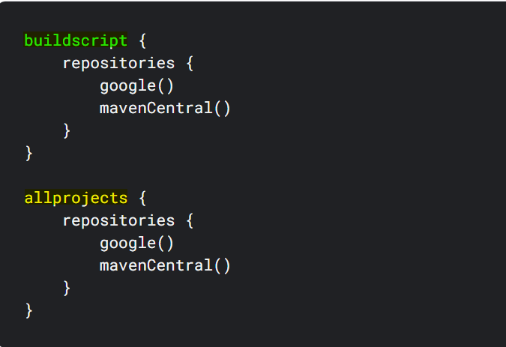



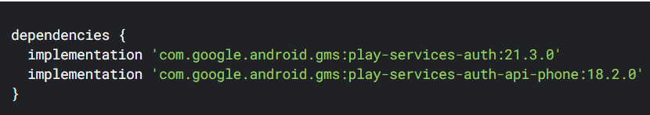

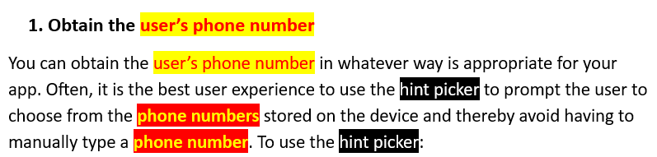

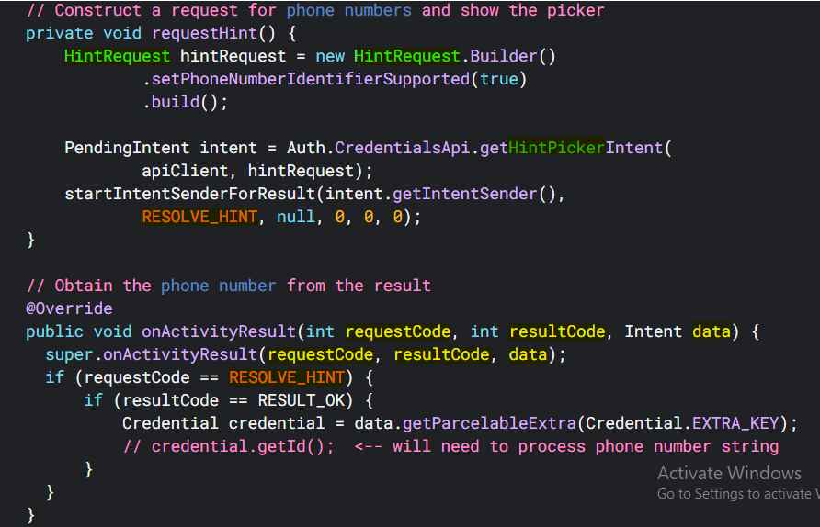

**In kotlin below**

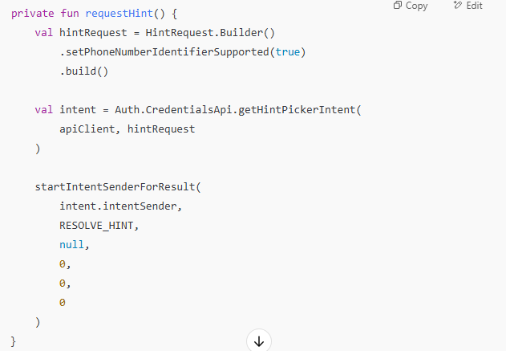

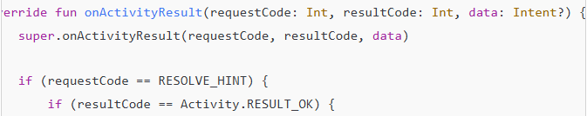



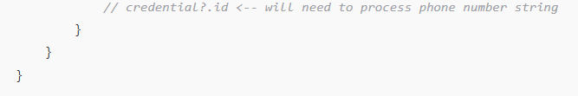

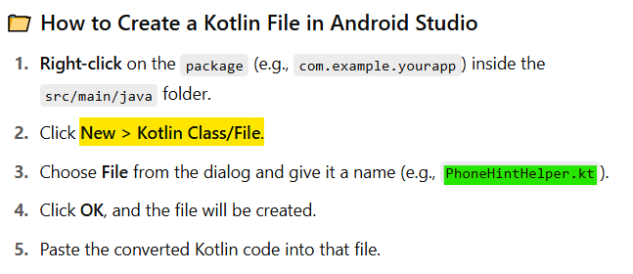

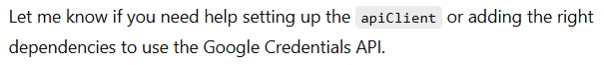

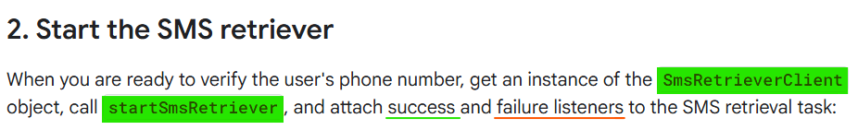

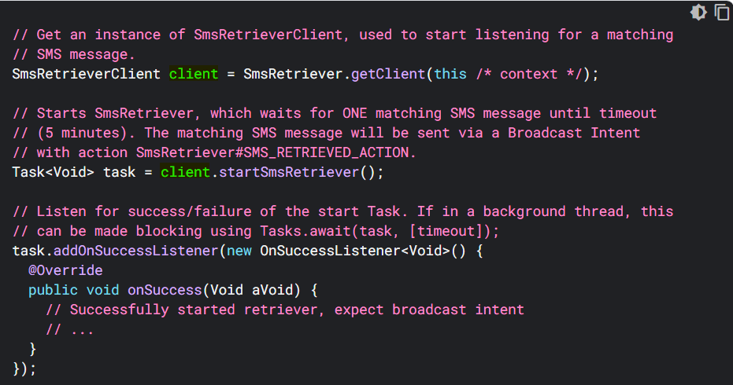

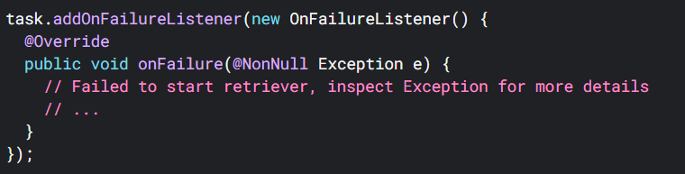



**in Kotlin code below**

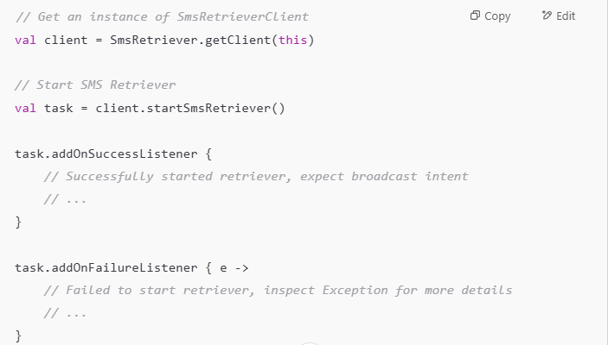

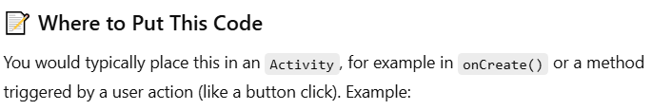

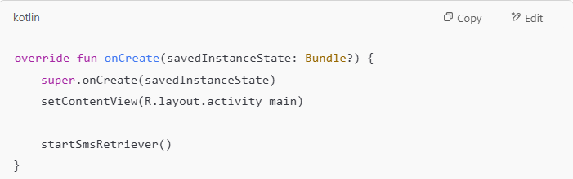

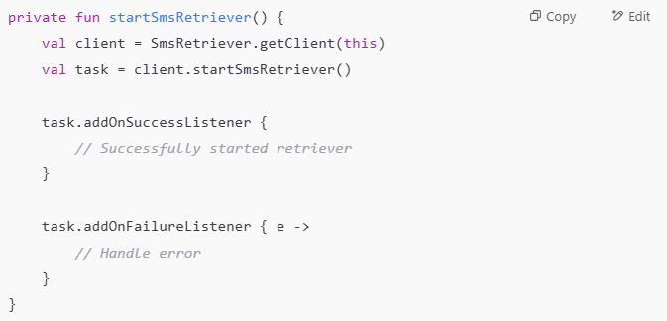

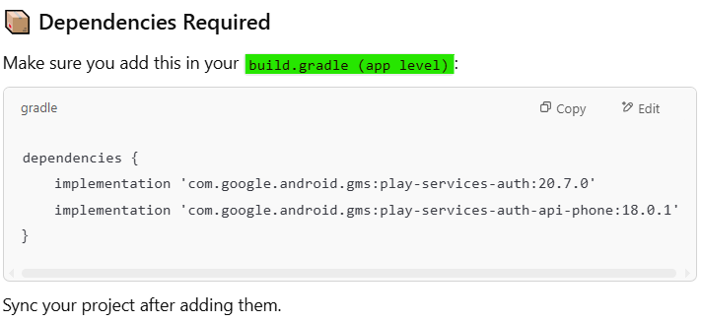

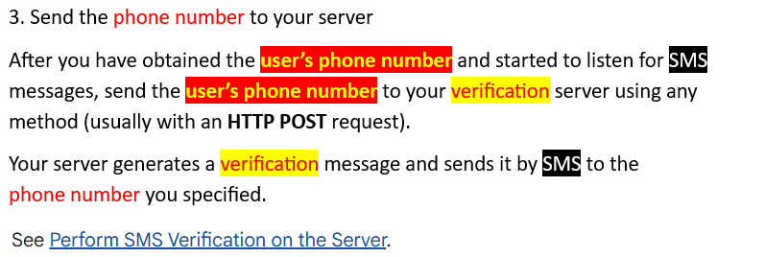

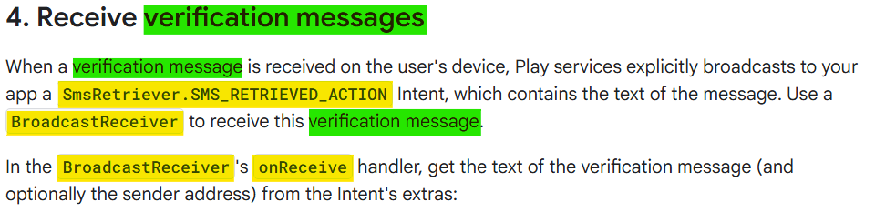

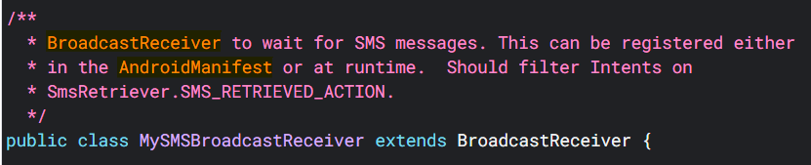

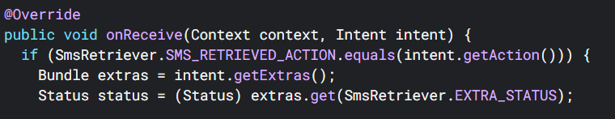

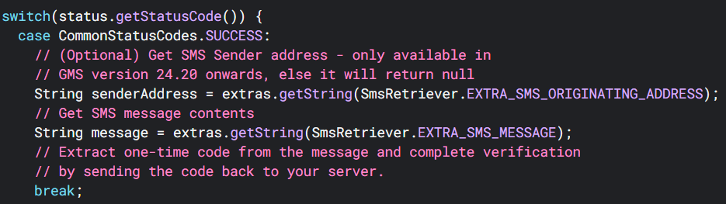

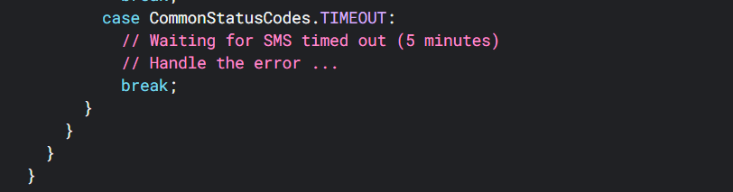

**in kotlin below**

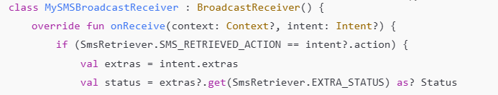

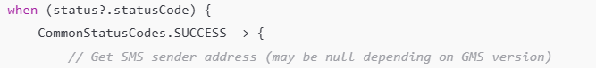

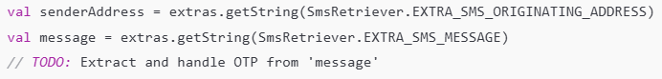

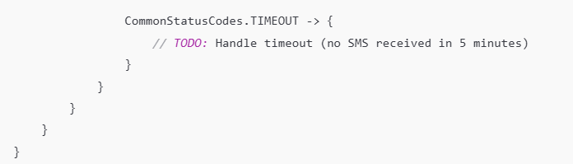

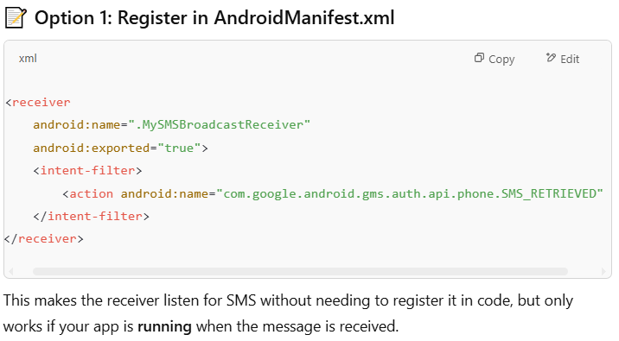

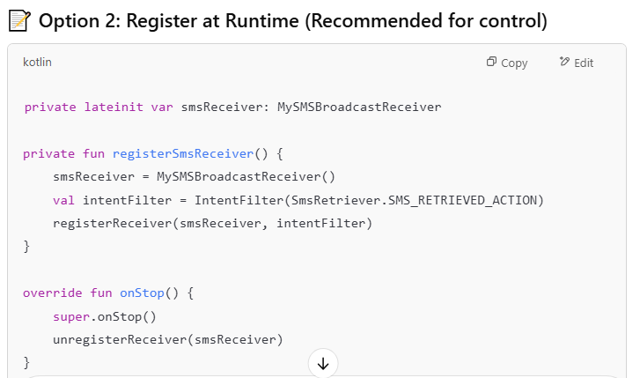

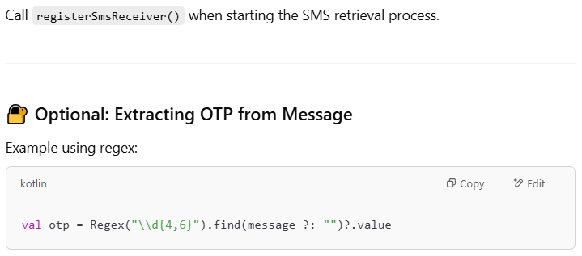

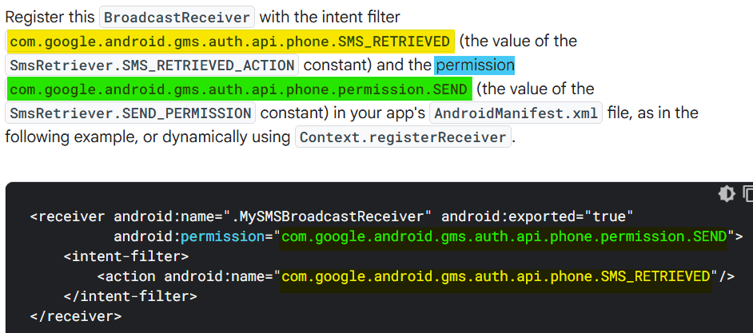

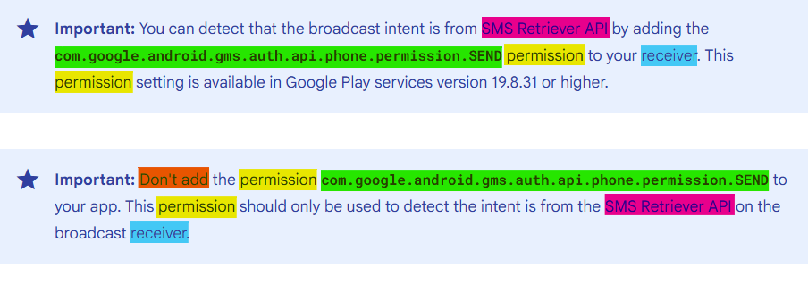

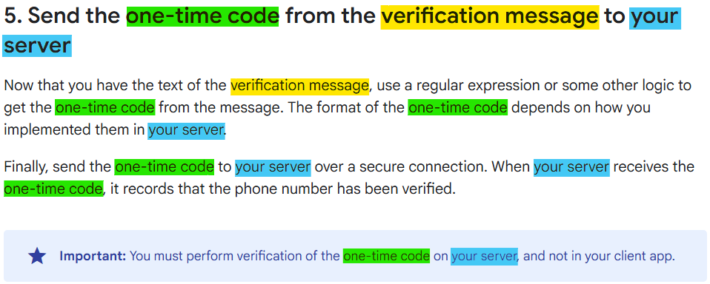

[**https://developer.android.com/build/annotation-processors**](https://developer.android.com/build/annotation-processors)

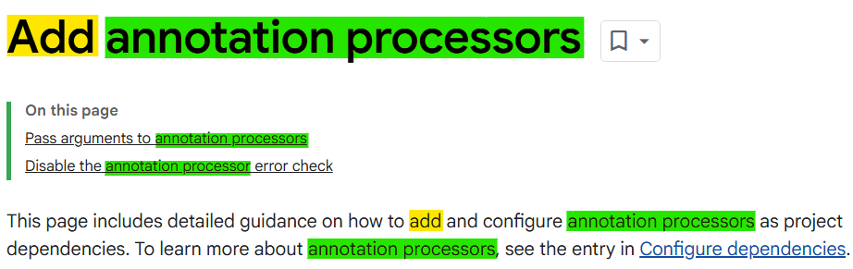

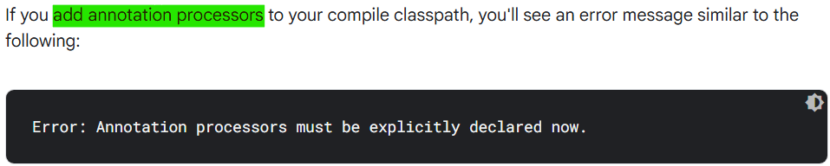

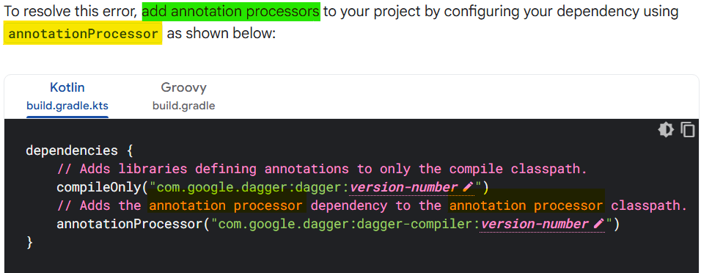



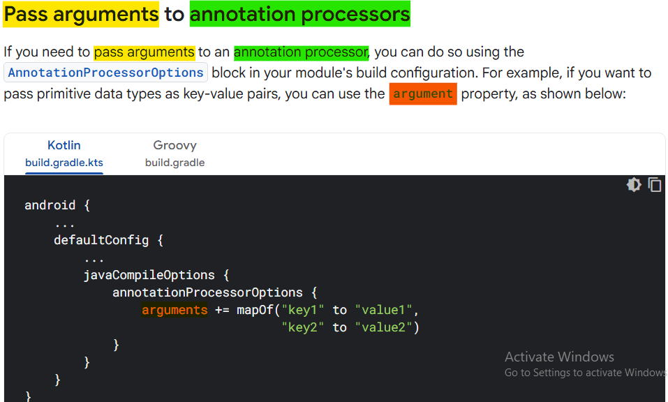

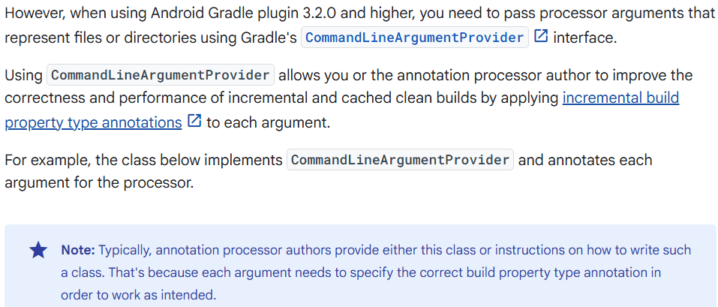

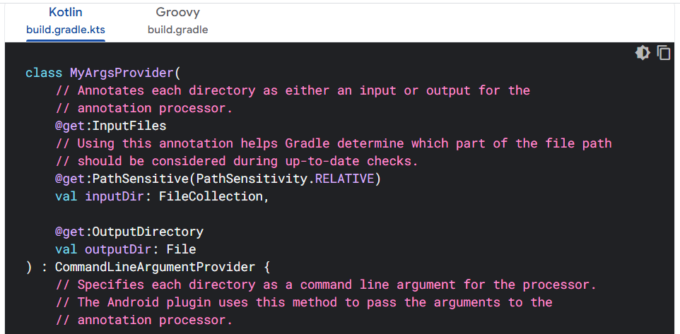

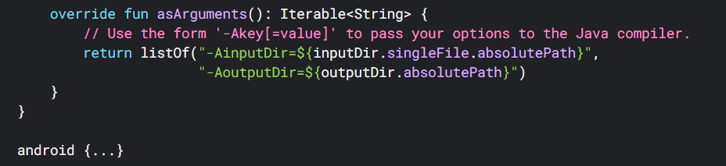

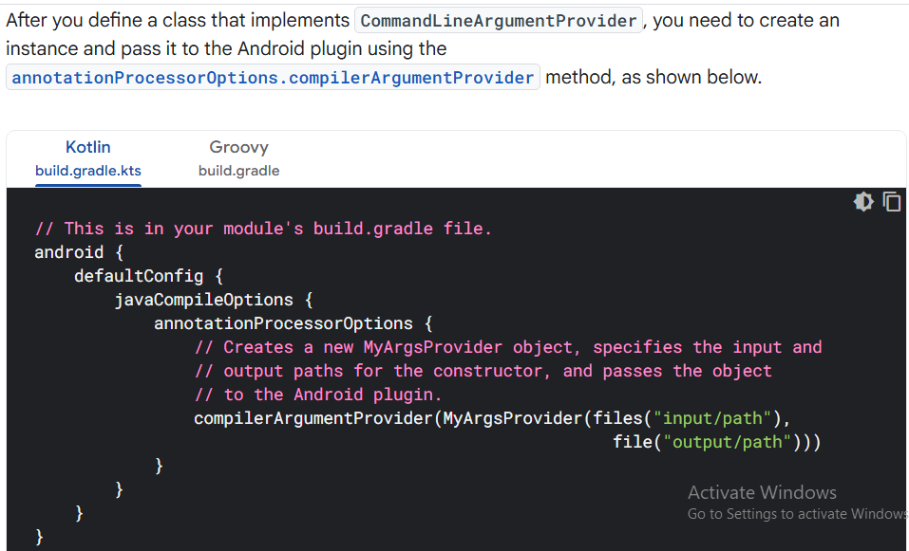



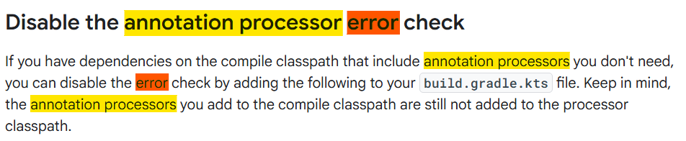

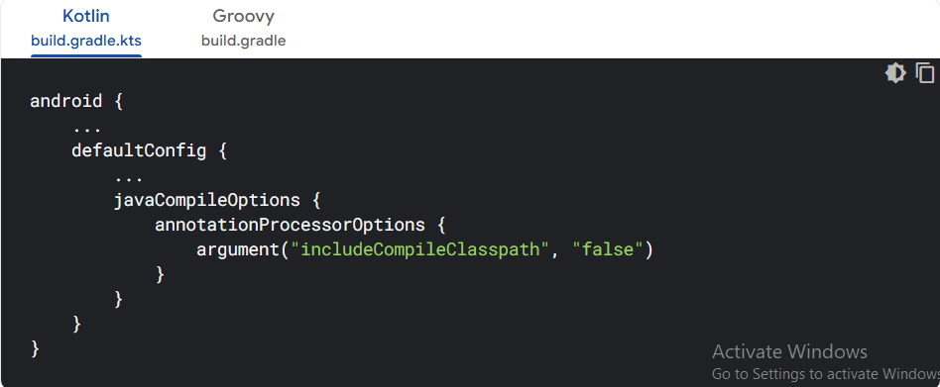



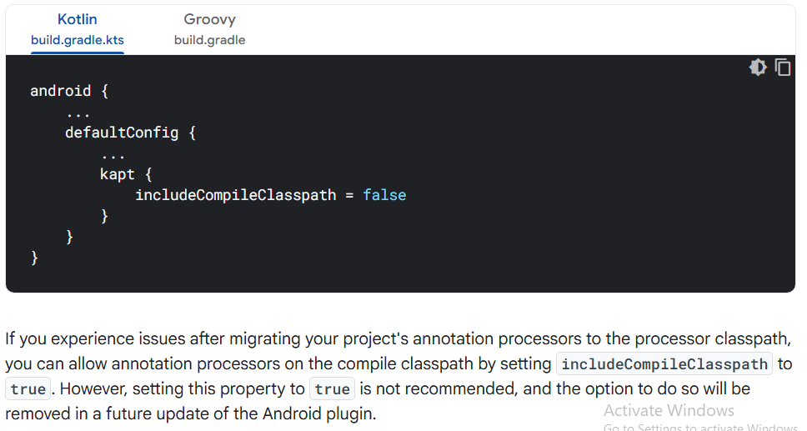

<https://developers.google.com/maps/documentation/android-sdk/examples>

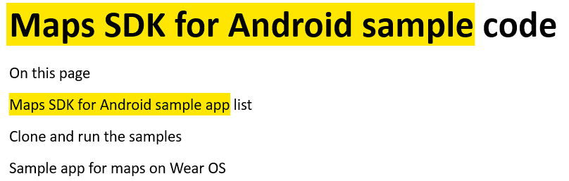

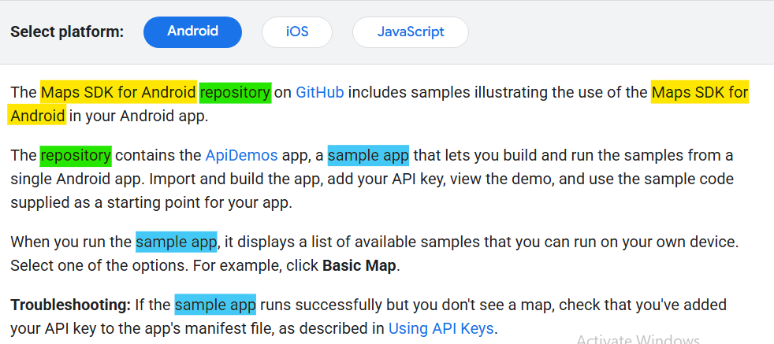

<https://developers.google.com/codelabs/maps-platform/maps-platform-101-compose#0>

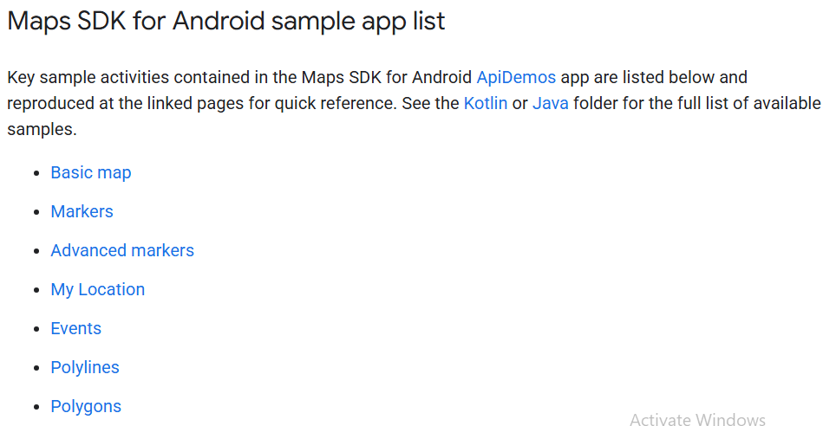

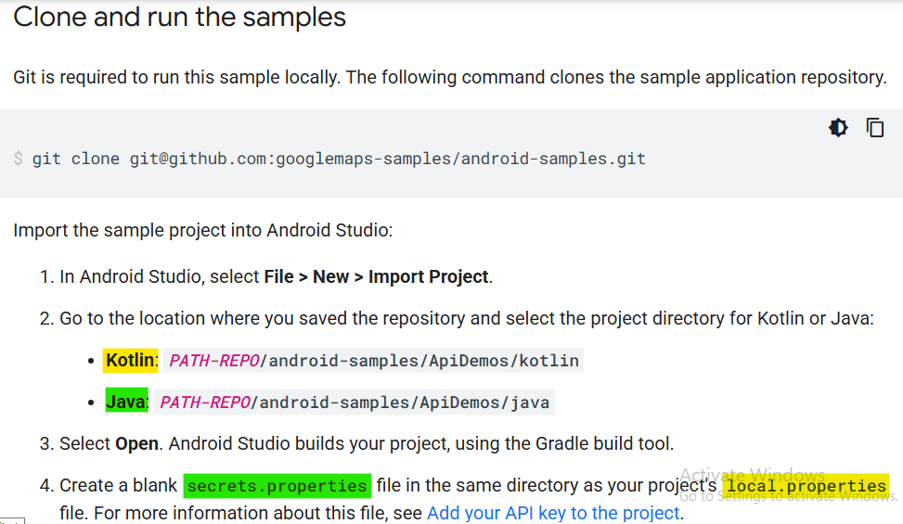

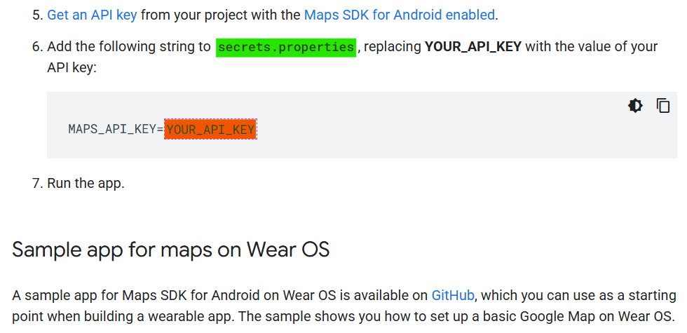

<https://developers.google.com/codelabs/maps-platform/maps-platform-101-compose#1>

